Spelling City http://www.spellingcity.com/
Features: To help students practice their spelling, especially of word lists or vocabulary you provide them in class, online exercises may be helpful, and this online spelling program is a free and easy way for you to provide online opportunities to students for learning the spelling of words and hearing pronunciation in model sentences.
For a given word list, there are three activities:
- Test Me: Students hear each word and a sentence using the word and type in the target word.
- Teach Me: Students hear and see a word as it is spelled on screen letter by letter and then hear a sentence using the word.
- Play a Game: Students practice with a word search, “HangMouse,” unscramble, or word matching exercise.
Teachers can use the Student Record Keeping feature (https://www.spellingcity.com/student-record-keeping.html) if they want to register at the site and set up a home page where lists of words can be saved by the week, or they can span an entire year. The lists will be saved until they delete them. Students can login at home for more practice. Teachers can share a list by email/linking, or students can find lists by searching for a teacher.
Uses: Listening, spelling, dictation, vocabulary exercises.
How to create and edit word lists on SpellingCity:
- Go to www.spellingcity.com and select “Register.”
- Fill out the form and select the register button.

- Log in to your email account you used to register and click on the link in the confirmation email.
- Log in with your username or email and password and select “Login.”
- Select “List Management” from the Teacher’s Toolbox (top right) to view, create, and edit lists.
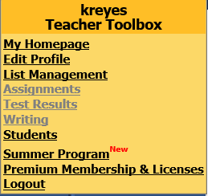
- Select “Create a New List.”

- Type in a title for the list. Select “Batch Entry” to copy and paste a list of words or type in the words one by one in the text boxes. Select Save.
To edit lists:
- After logging, select “List Management” in the Teacher Toolbox. Select “Edit” under the “What do you want to do” column for the list you want to edit.
- In the editing box, select on the sentence, definition, or part of speech you wish to edit.
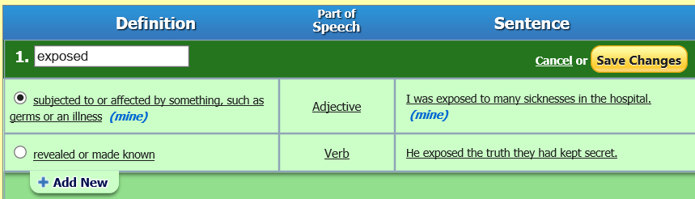

- The default sentence is what will be read to students in the audio of the exercises. Select the default sentence to be able to see a text box where you can edit the sentence.
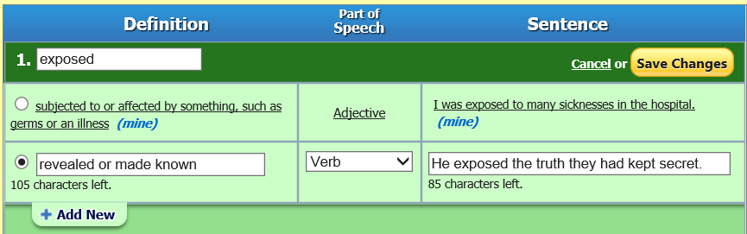

- Delete a word by hovering over the word and clicking the Delete link on the right.
- Select one of the blue action buttons (see below) for more list editing and management options: Select the “Add a Word” button to add words to the list, the “Word Order” button to change the organization of the words to random or alphabetical, and/or select the “Visibility” button to Publish List (Select "Yes" to have list appear on your homepage).
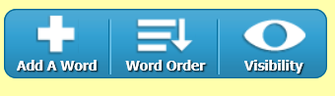
- Select “I’m finished” when you have completed editing a list. The list will be added to the List Management section of your account.
How students can access the lists you create:
- Tell students to go to the site and select “Find a List.” Then students can search for any of your published lists by tying in your first and/or last name, your username, or the title of the list(s).
- You can also e-mail the URL of a list to students or link all your lists on a class Web page.

