Accessing Spelling City Learning Activities & Games
Instructions for Students
www.spellingcity.com

Step 1: Visit the Web site: www.spellingcity.com

Step 2: Select “Find a List”

Step 3: Enter your teacher’s name, select Teacher Name from the menu and select Search.

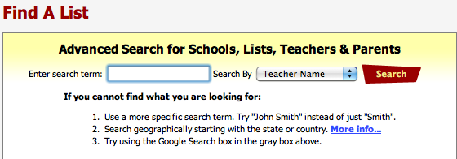

Step 4: Select your teacher’s name in the search results.

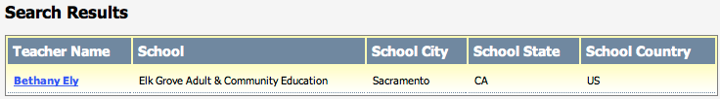

Step 5: Look for the list you would like to practice and select Games.

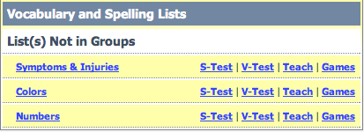

Step 6: Select one of the Learning Activities and Games from the list.

