# Voki Directions

*If you have an e-mail account (if not, see more below):*

## Step 1:

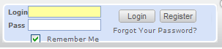

* 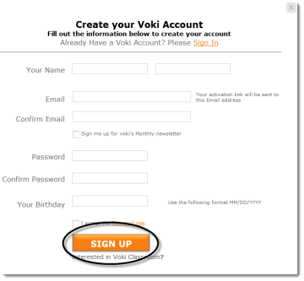Go to [www.voki.com](http://www.voki.com).
* Register for an account.
* Select **Register**.
* Fill out this simple form and select **SIGN Up**.
* Close the dialog box:

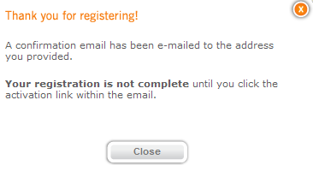You will be sent a confirmation e-mail. Login to your e-mail account and select the Voki Activation link. You can now log in and create your Voki. Note: Sometimes the Voki confirmation e-mail gets sent to junk folders. Make sure to check there if you do not see the e-mail in your inbox.

## Step 2:

* Now log in using the login name and password you created earlier.
* 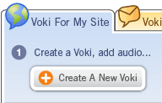You will need to agree to the terms of use and

select **Continue**.

* Create your Voki!

*If you do not have an e-mail account:*

* Go to [www.voki.com](http://www.voki.com).
* Select the **Create** tab.

Change coloring and dimensions.

* Customize your Voki.   
  Note: If you do not register for Voki with an e-mail account, you will not be able to use your Voki again in the future.

## Step 3:

* Customize your Voki.
* Choose **Create a New Voki**.

Record a message by phone, text to speech, computer microphone, or upload a sound file.

Choose background and a player (frame).

Choose character, clothing, and accessories.

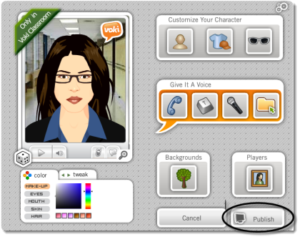

* Publish your Voki.

From here you can view your voki, e-mail it, edit it, or delete it.

If you created an account, you can make more Vokis. You will see these options:

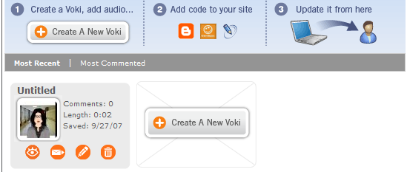



To embed on a Web site:

* Select the **Publish your Voki** button.
* Choose the size of the player (large or small).
* Choose the destination.
* Select **Get Code**.
* Choose to **Agree to terms**.
* Now, copy the HTML code in the box. (Select the **[Ctrl]** + the **[C]** keys to **Copy**):

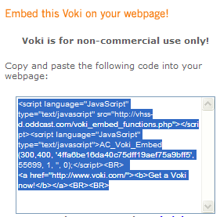

* On the Web page, choose the **Edit** .html option. Paste using the [Ctrl] + the [V] keys to paste the .html code.