Sample Colors Word Cloud made on Word It Out
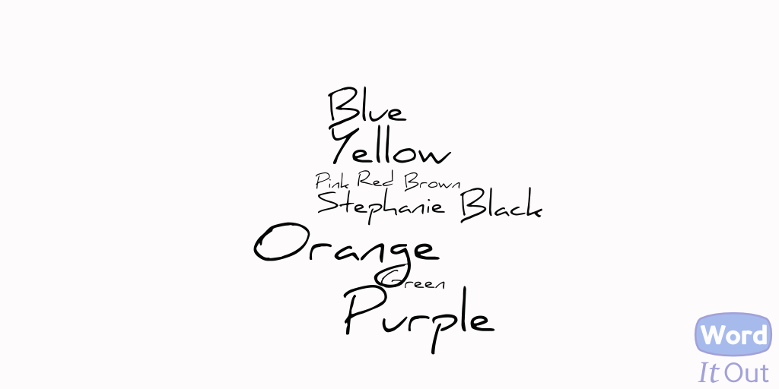

Sample Vocabulary List – Personality – made on Word It Out
