Over-the-Counter (OTC) Drug Labels

Antihistamine label
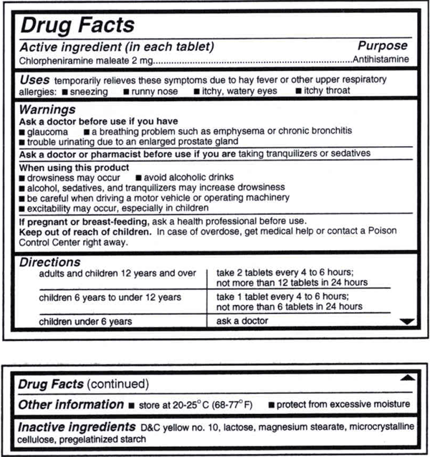

Acid reducer
