To use Microsoft Word Readability Statistics and Synonyms:
To check for reading level:
- Type in text
- In Mac OS X, go to the Word drop down menu. ... For PC Click the Microsoft Office Button, and then click Word Options.
- Select Spelling and Grammar.
- Check Show readability statistics and click OK.
Now when you use the spell check tool, it will automatically tell you the Flesch-Kincaid grade level equivalency.

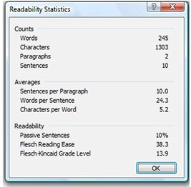
Optionally, revise and check spelling and grammar again until the writing reaches a given grade level.

Follow these steps for replacing low-level words with more academic or higher-level words in order to increase the grade level of the writing:

- On a PC, right-click on a word to see a menu with the option Synonyms.
- Choose Synonyms, and a list of words as well as a thesaurus link are displayed.
- Choose a synonym to replace a given number of words in their paragraphs (for example, you may suggest that they replace all nouns and adjectives that are four or fewer letters).
- Complete the spell check once again and record the new readability statistics, comparing the first draft grade level with the new grade level.
- Save and print the paragraphs or submit them to the instructor electronically, such as via e-mail as an attachment.

