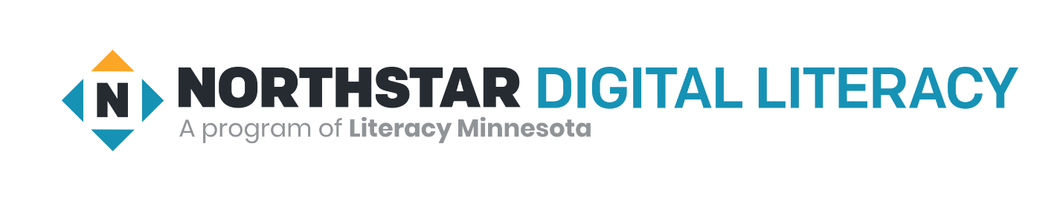

Thank you all to attended our recent OTAN webinar on Northstar Digital Literacy Assessments and Curricula. While many components of Northstar are available only through subscription, we do have some aspects that are free to all.
- The 12 Digital literacy assessments can be found on our website, https://www.digitalliteracyassessment.org/ and are always free to whomever wants to take them
- Our Northstar Online (NSOL) Computer Basics module is currently available on our website and free to all until at least the end of May. This may be extended depending on how the pandemic progresses. https://assessment.digitalliteracyassessment.org/basic-computer-skills/practice/getting-started-with-computers

