# Create Polls, Quizzes and More Using Crowdsignal

1. Sign up for Crowdsignal using a Google account or create a new account at WordPress.com

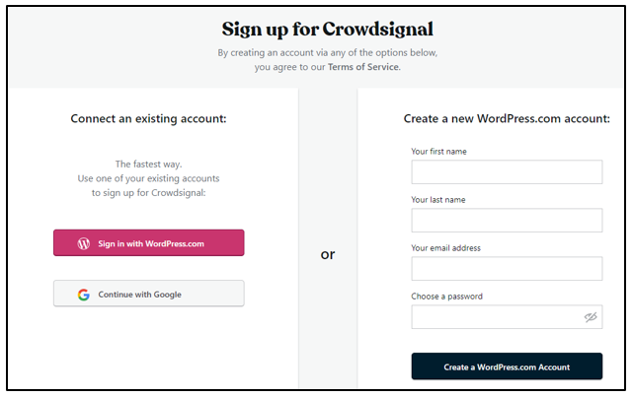

1. Select your project: survey, poll, quiz or rating.

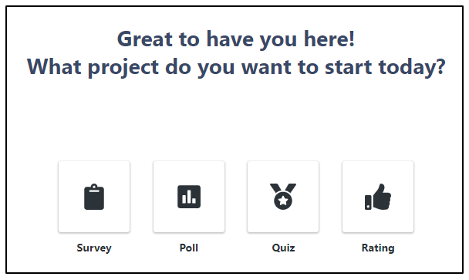

1. For a Poll:

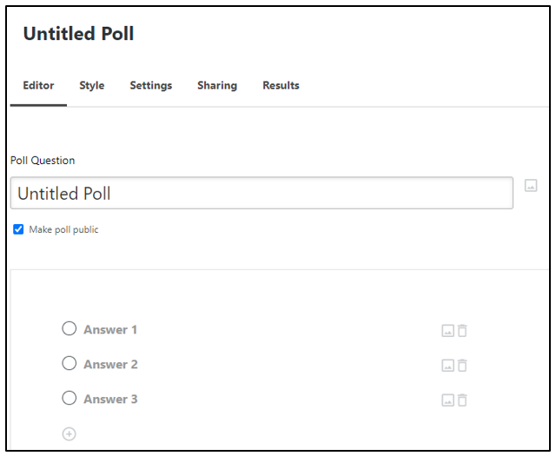

For example:

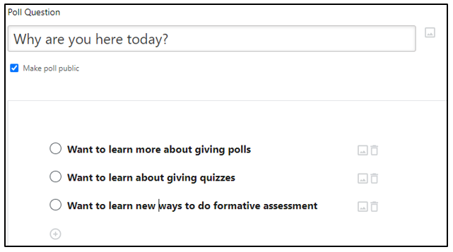

1. Along the top there are choices. Choose your Style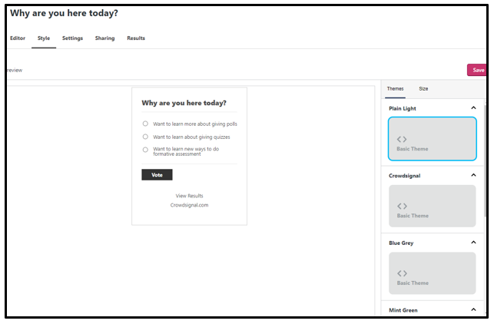
2. Under Settings you can select answers, comments, or results

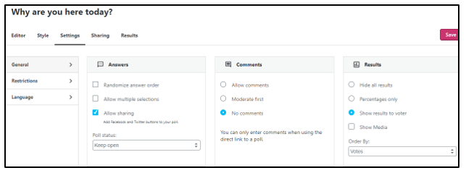

1. Under Sharing you can use Link, Embed, Website Popup or Email 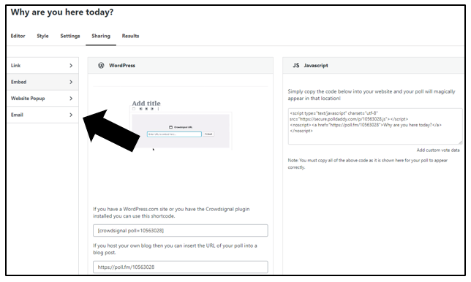
2. Under Results you can look at Overview, Individual Votes, Voter emails, IP Analysis and Location

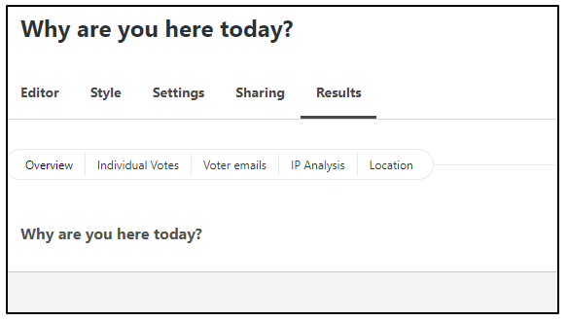

1. If you click on Dashboard you go back to Create New

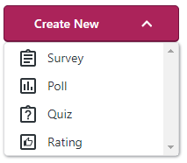

1. Beside Dashboard you can select Contacts. There you can see a record of those you have contacted or create a group.
2. Down the left you can select My Content where you can see a quick view of what you have created and responses.

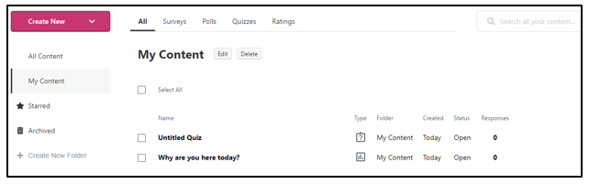

1. Under Help you access the Support Center where there are tutorials, guides and additional help articles.

