Enrolling in Applied Digital Skills
- Go to the website, g.co/AppliedDigitalSkills . 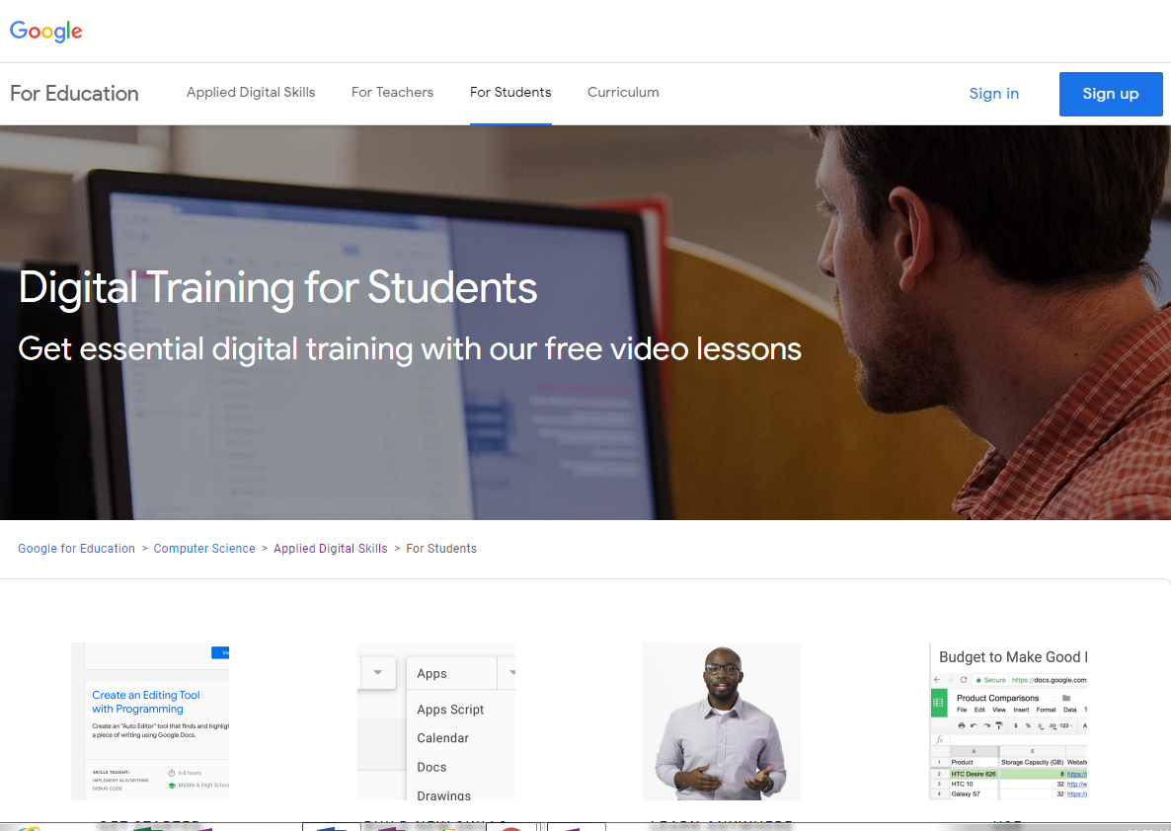
Caption: Website for students accessing Digital Training. Select sign in
- Sign in using your g-mail or google account. (to use this application you will need a g-mail or google account).
- Select I am a student, and enter your class code. (see the teacher for the class code).
- Put on your earphones.
- The next screen includes a video to welcome to your course. It will tell you how the course works, and ways you can change the screen/ volume, etc.
- Click on the lesson your teacher has selected.

