Voki Directions
If you have an e-mail account (if not, see more below):
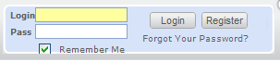

Step 1:
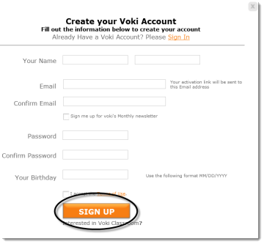
- Go to www.voki.com.
- Register for an account.
- Select Register.

- Fill out this simple form and select SIGN Up.

- Close the dialog box:

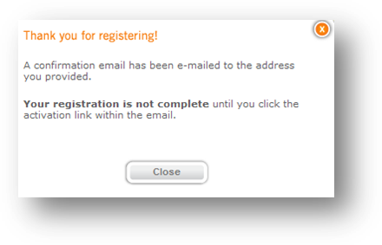
You will be sent a confirmation e-mail. Login to your e-mail account and select the Voki Activation link. You can now log in and create your Voki. Note: Sometimes the Voki confirmation e-mail gets sent to junk folders. Make sure to check there if you do not see the e-mail in your inbox.

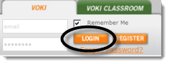
Step 2:
- Now log in using the login name and password you created earlier.
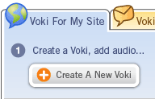
- You will need to agree to the terms of use and
select Continue.
- Create your Voki!

If you do not have an e-mail account:

- Go to www.voki.com.
- Select the Create tab. 
Change coloring and dimensions.

- Customize your Voki.
Note: If you do not register for Voki with an e-mail account, you will not be able to use your Voki again in the future.
Step 3:
- Customize your Voki.
- Choose Create a New Voki.
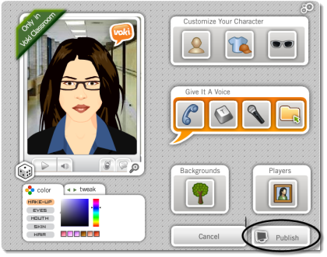
Choose character, clothing, and accessories.

Record a message by phone, text to speech, computer microphone, or upload a sound file.

Choose background and a player (frame).
- Publish your Voki.
From here you can view your voki, e-mail it, edit it, or delete it.
If you created an account, you can make more Vokis. You will see these options:
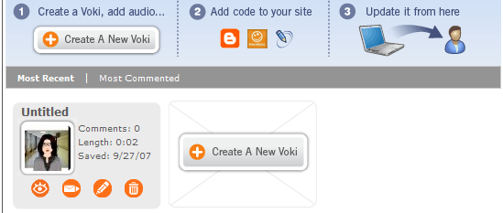


To embed on a Web site:
- Select the Publish your Voki button.
- Choose the size of the player (large or small).
- Choose the destination.
- Select Get Code.
- Choose to Agree to terms.
- Now, copy the HTML code in the box. (Select the [Ctrl] + the [C] keys to Copy):
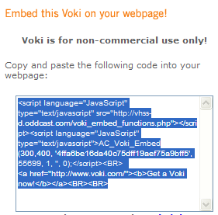
- On the Web page, choose the Edit .html option. Paste using the [Ctrl] + the [V] keys to paste the .html code.

