Kristi Reyes

11/30/13

Level 7 ESL

Geography Assignment

Fantastic Places in the USA: Devil’s Tower

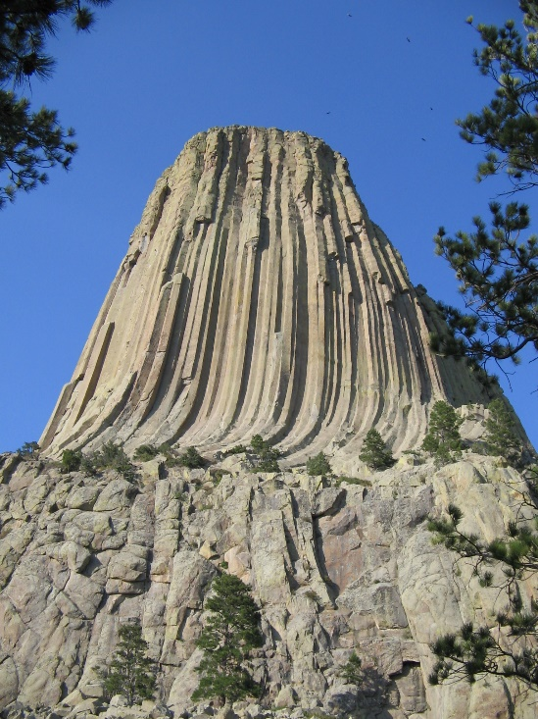 [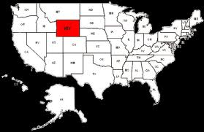](http://www.google.com/imgres?hl=en&qscrl=1&rlz=1T4GGLS_enUS559US560&biw=1412&bih=684&tbm=isch&tbnid=4S2KtNOl9XNMTM:&imgrefurl=http://www.myonlinemaps.com/wyoming.php&docid=39kTv6wzxJSlwM&imgurl=http://www.myonlinemaps.com/images/wyoming-map.gif&w=480&h=312&ei=BziZUoOiEIL5oAS-yYKACw&zoom=1&iact=rc&page=2&tbnh=173&tbnw=267&start=10&ndsp=22&ved=1t:429,r:31,s:0&tx=146.2999267578125&ty=32.040008544921875)[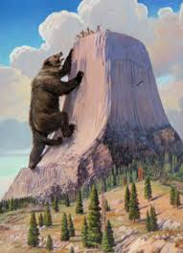](http://www.google.com/imgres?sa=X&hl=en&qscrl=1&rlz=1T4GGLS_enUS559US560&biw=1412&bih=684&tbm=isch&tbnid=2HxgSZzPp2-ClM:&imgrefurl=http://moosedroppings2010.blogspot.com/2010/04/friday-apr-16-devils-tower-wyoming.html&docid=a63vm1L9zk8ZhM&imgurl=http://2.bp.blogspot.com/_KNqKWWMKBJY/S8k4OCJenEI/AAAAAAAAAVY/pmNNh9rug6k/s1600/Devils%252BTower%252Blegend.JPG&w=1156&h=1600&ei=uzeZUtyQKJTYoASHpYKwDQ&zoom=1&ved=1t:3588,r:78,s:0,i:345&iact=rc&page=4&tbnh=190&tbnw=151&start=60&ndsp=24&tx=83.58999633789062&ty=105.78999328613281)

Location: Devil’s Tower is located in northeastern Wyoming.

How it was formed: This 1000-foot tall monolith was formed by molten igneous rock at the throat of a volcano. It was shaped by wind and water over time. The outer layers of the volcano were worn away, and what stands now is the hard core of the volcano.

Interesting facts: According to native American Legend, Devils Tower was formed by supernatural powers. The legend says that seven girls were attacked by bears and ran to the top. The Rock God made the rock grow so that it rose and the girls were safe, while the rock’s gouges on the sides were formed by the bear clawing and scratching at it to try to get to the girls. The legend says that the girls can be seen above the rock on a clear evening as seven bright stars.

Devils Tower was named the United States’ first national monument by Theodore Roosevelt in 1906. Today it is a park enjoyed by rock climbers.