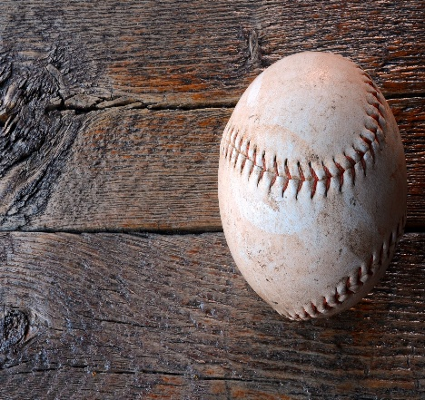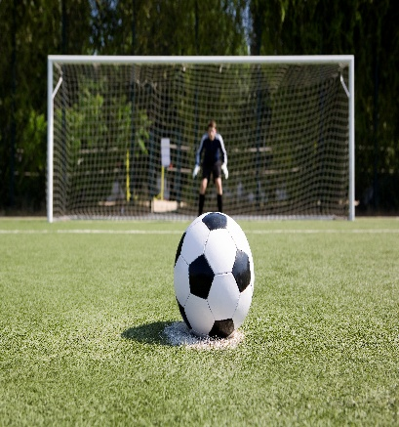
Can you name the sport with the picture?
What exercises can you do with each?

Baseball Soccer

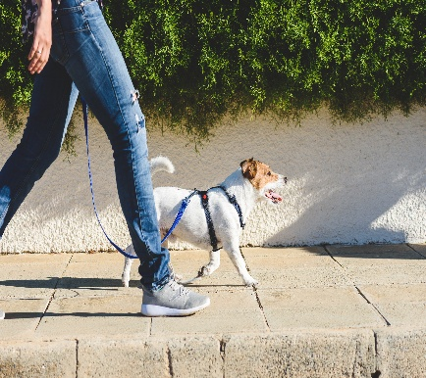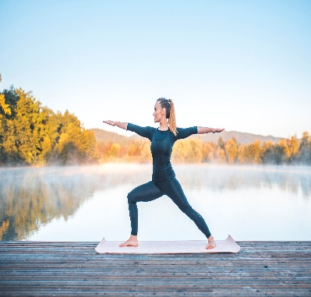
Walking Yoga

All photos license free, Microsoft , creative commons
E.Doonan,2026,OTAN

