Dr Martin Luther King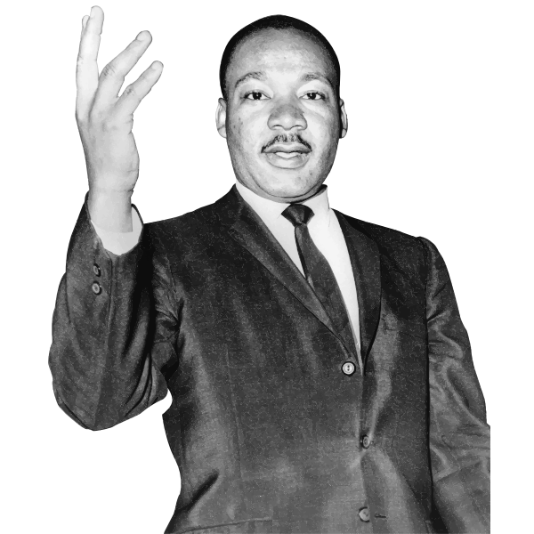

Dr. Martin Luther King Jr. was the most important leader of the American civil rights movement. He helped unite a nation with his powerful speeches and use of non-violent protests. His 1963 “I Have a Dream” speech is one of the greatest in human history. King’s efforts to end racial discrimination earned him the Nobel Peace Prize in 1964.
King was born in 1929 in Atlanta. His father was a reverend and so King had a religious upbringing. He graduated from college with a degree and a Ph.D. in religious studies. King went to India to visit Gandhi’s family. He was inspired by Mohandas Gandhi's success with non-violent resistance and saw it as a “potent weapon” in America’s struggle for civil rights.
King was instrumental in achieving many successes in ending segregation laws. He led the Montgomery Bus Boycott which ended racial segregation on public buses in Montgomery. He realized that non-violent protest would attract extensive media coverage of the struggle for racial equality. His campaigns soon elevated the Civil Rights Movement to be the most important issue in American politics.
King helped organize the famous March for Jobs and Freedom on Washington in 1963, where he spoke to the nation appealing for racial harmony. His non-violent protests met with success as Congress passed civil rights laws (1964) and voting rights laws (1965). King’s friendship with President John F. Kennedy also helped his cause. King was assassinated on April 4, 1968. Stevie Wonder pays tribute to King with his song "Happy Birthday".
Sources: http://www.wikipedia.org/ and assorted biographies.

Match the words from the article on the left with their synonyms on the right. Are your answers the same as other students’?
Word Match
Paragraphs 1 and 2
1. | unite _____ | a. | racism
2 | protests_____ | b. | battle
3. | discrimination_____ | c. | demonstrations
4. | inspired_____ | d. | powerful
5. | potent_____ | e. | join
6. | struggle_____ | f. | motivated
Paragraphs 3 and 4
7. | instrumental_____ | g. | mission
8. | realized_____ | h. | wide
9. | extensive_____ | i. | understood
10. | appealing_____ | j. | important
11 | cause_____ | k | killed
12 | Assassinated _____ | l | asking

Phrase Match
Match the following phrases from the article:
1. | leader of the American civil _____ | a. | discrimination
2 | He helped unite a nation with_____ | b. | with non-violent resistance
3. | end racial _____ | c. | with success
4. | King had a religious_____ | d. | laws
5. | inspired by Mohandas Gandhi's success_____ | e. | his powerful speeches
6. | ending segregation__________ | f. | in American politics
7. | attract extensive media_____ | g. | for racial harmony
8. | the most important issue_____ | h. | upbringing
9. | he spoke to the nation appealing_____ | i. | rights movement
10. | His non-violent protests met_____ | j. | coverage

