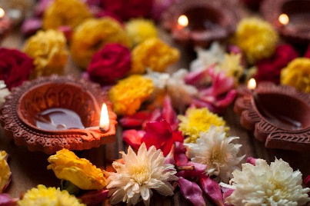

Day of the Dead

1. What is Day of the Dead?
2. Can anyone celebrate this holiday?
3. Is this just another Halloween?
4. Are there movies about Day of the Dead?

Document: E.Doonan 2025

Photo Microsoft free image