Padlet padlet.com (formerly Wallwisher)

Features: A way to take class bulletin boards online, jazz them up with multimedia, and even include in class assignments. Only the person who makes a notice board (called a “wall”) needs to register. Anyone who contributes to the wall with a Post-it-like message only needs to double-click and type. (There is a maximum of 160 characters that can contain images, audio/music, video, and hyperlinks to other Web sites.) Registered users who make a wall can set the following privacy options:
- Anyone can view posts or only the user
- Anyone can post or only the registered user
- Moderation (view and approve posts before they are added to the wall) or Un-moderated (allow all posts to appear).

Walls can be shared via many methods (see below).

Uses: There are several potential uses of Padlet in the classroom.
Teachers can:
- post a question and ask students to post their responses as a pre-reading activity or to use as the basis of a discussion or as a post-reading reflection.
- provide class information and announcements.
- ask students to contribute suggestions for class or to evaluate an activity.
- assign students to post a self-evaluation or peer review for a class assignment or project.
- use as a discussion board for a given topic or debate.
- document learning goals for the class.
Students can:
- post introductions of themselves.
- post short biographical or autobiographical sketches.
- tell about their jobs.
- share holiday or family traditions.
- document educational or career goals.
- write and share poetry.
- add a book or movie review.
- share things to do and see in the city where they live.
- recommend best restaurants, stores, coffee shops, places to study.
- write about the place of their birth or where they live now.

Both teachers and students can share favorite Web sites, videos, and other online resources for learning.
For many other ideas for using Padlet (formerly Wallwisher) and sample walls, see the following:
- Sean Banville’s blog entry, “Wallwisher – 105 Classroom Ideas” at http://seanbanville.com/2010/06/26/wallwisher-105-classroom-ideas/
- Nik Peachy’s Learning Technology Blog entry, “Using Online Sticky Noticeboards” at http://nikpeachey.blogspot.com/2009/04/using-online-sticky-noticeboards.html for ideas to use Wallwisher with ESL students
- The Thinking about Learning blog post, “Wallwisher in the Classroom” at http://friedafoxworth.edublogs.org/2010/03/21/wallwisher-in-the-classroom/ for ideas on using the site in many different subject areas and a video tutorial
- Mark Warner’s Ideas to Inspire Web site’s “31 Ways to Use Wallwisher in the Classroom” at http://www.ideastoinspire.co.uk/wallwisher.htm, with examples of ways K-12 teachers in the U.K. and elsewhere are using the site
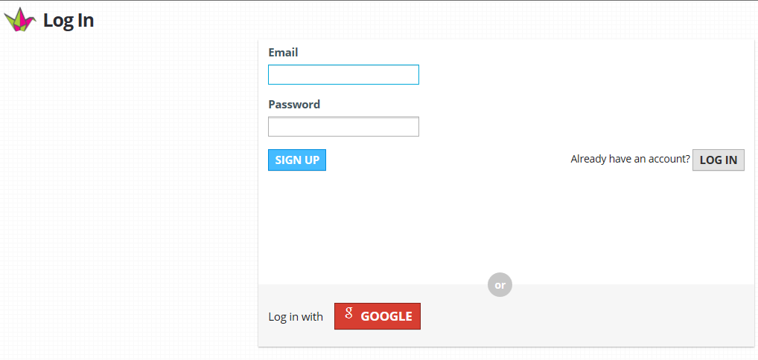
How to:

1. Go to http://padlet.com/. Sign up for an account and log in. You can simply log in without registering if you use a Google email (gmail) account..

2. Select the big “+” sign  or “Build a wall.” 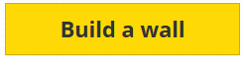

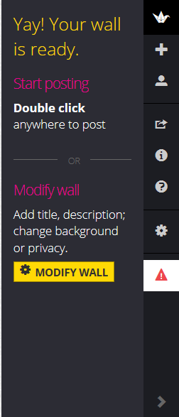
3. You will see your blank wall and the tools on the right of the screen.

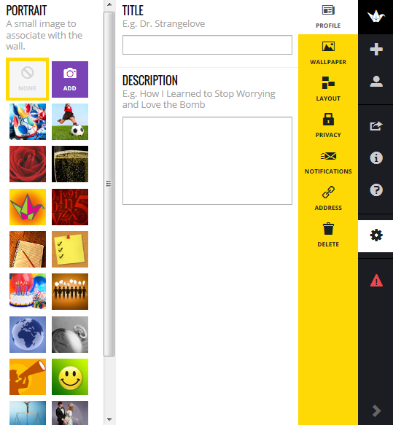
Select “Modify Wall” to add a small image to associate with the wall (similar to a logo), add a title, and enter a description.

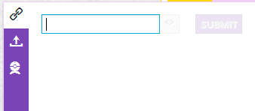
You can choose from the site’s images by choosing one or select the Add box. There are three methods for adding your own background image:

A) Select the link and enter the URL for a Web image and select Submit.

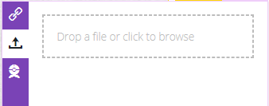
B) Upload a photo by choosing the upload icon and clicking the box to the right to browse for the image. Once the image has uploaded, select Submit.

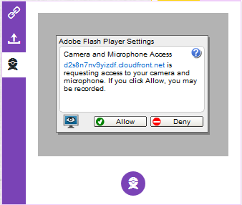
C) Take a photo with a Web cam by selecting the Web cam icon. Make sure to select Allow in the Adobe Flash Player box and then take a photo by selecting the Web cam icon at the bottom of the box.

4. Select Wallpaper to add a background image.

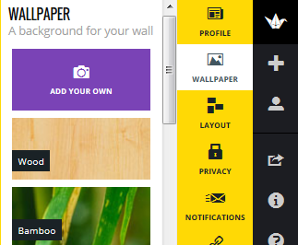
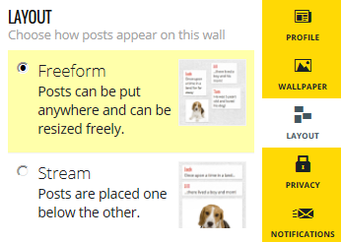
Select any one of the site’s backgrounds to use it or select Add Your Own to use a Web image, upload an image, or take a Web cam photo (follow same directions as in # 3).

5. Next, select Layout to choose how items posted on the wall will be arranged (Freeform – anywhere and resized freely or Stream – below one another).

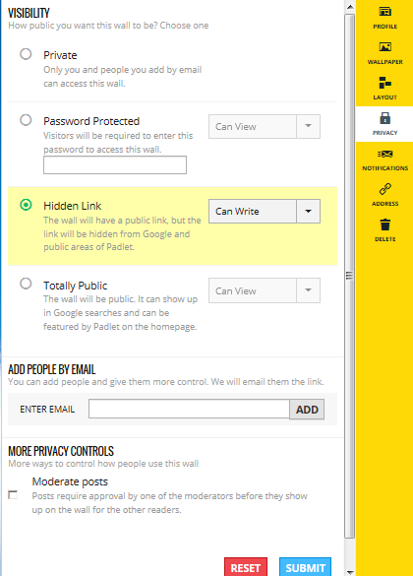
6. Select Privacy to select options for who can access the wall, password protection, who can view the wall, who can post to the wall, and moderation of wall posts. Select the drop-down arrows to make choices and select Submit to save.

7. Selecting “Send me an e-mail” in “Notifications” will alert you when someone has posted to your wall.

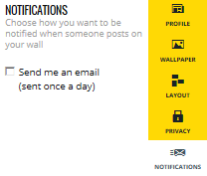
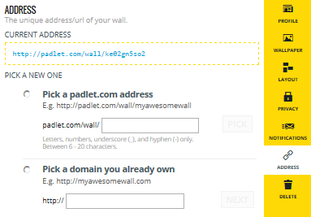
8. Click “Address” to view the URL for the wall or select “Pick a padlet.com address” to enter a customized URL for the wall by typing it in the box.

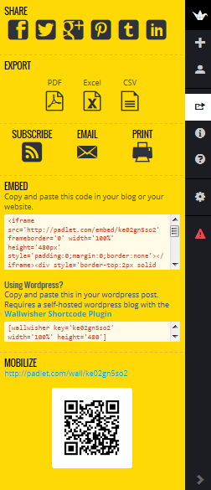
9. Click the “Share/Export” icon (fourth down on far right panel) for sharing options, which include posting the Wall on several social networking sites, exporting as files, emailing, printing, embedding, and sharing via QR code.

10. Anytime you need help, click on the question mark icon.
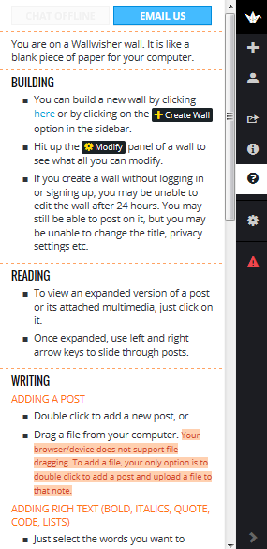

See also the Higher Ed Tech video tutorial at http://www.youtube.com/watch?v=DhAxV2Yp_Mw, the FAQs page at http://padlet.com/faqs, and the Padlet Junction page at http://jn.padlet.com/.
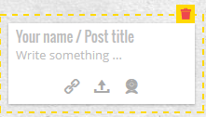
To add a message to a wall:
Double click anywhere on the wall.

In the box:
- type in your screen name or nickname and/or post title
- type in a message

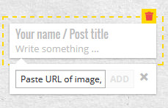
To add a hyperlink to a Web page, click on the link icon, enter a URL, and click “Add”

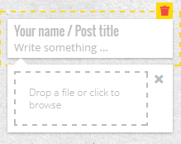
To add an image, click on the upload icon, click in the box to browse for a file, and select it by clicking on it. You can also add an image by clicking on the Web cam icon and taking a picture with a Web cam.

To remove a message, simply click on it and click on the delete (garbage can) icon in the top right corner.

