How to Use FreeWordCloudGenerator.com to Make a Word Cloud

1. Step 1: Go to the Website

0pen your internet browser

(Chrome, Firefox, Edge)


2. Click on Free Word Cloud Generator

3. Have students type or cut and paste text in text input. Note if you like students can get a word cloud of a You Tube Video as well.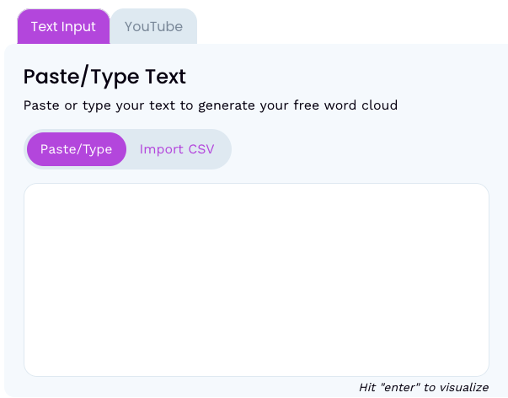

4. Hit enter to see your word cloud under your text.

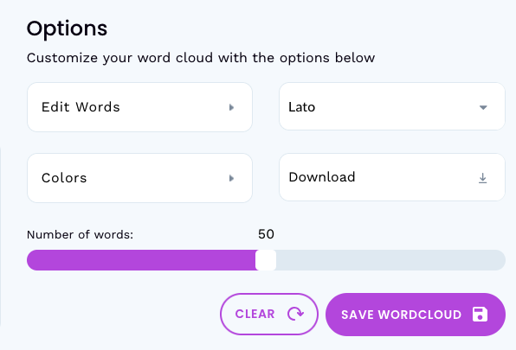
5. Students can edit, change the colors,

change the font or download

their word cloud

by using the option box on the left.

