How to use Padlet for the Adjective Activity

## Model these steps for your students.

1. Click on the plus button
2. Choose Image Search 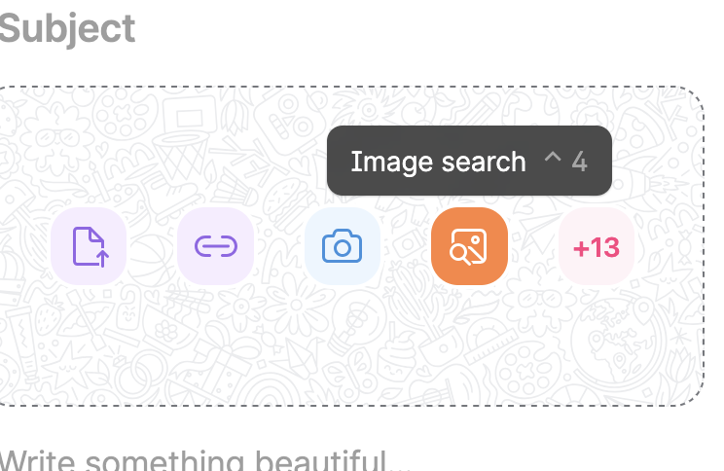
3. Show students how to type in a sentence in the box where it says to “search web”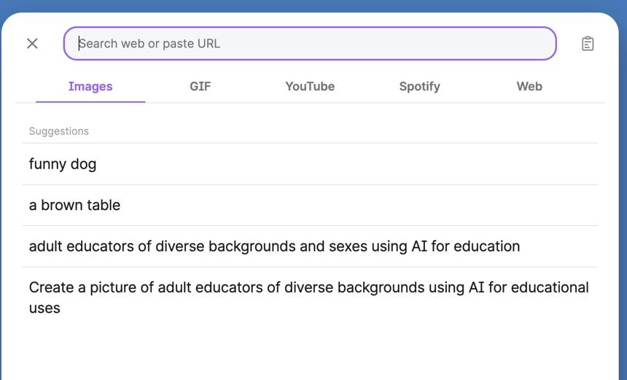
4. Choose a picture.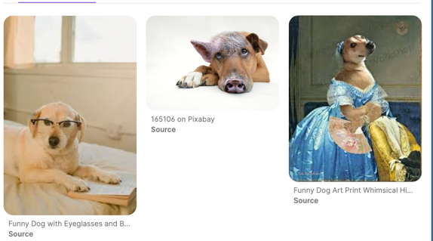

### Write their name and a caption. Click Publish.A dog that has features of a hourse. The caption reads: Susan Gaer: This is a dog that looks like a horse. It is a funny dog.

How to Share You Padlet with students.

### Click on the share arrow.Picture of a share arrow

### Choose whether you want to share the QR code or Share the Link.The Share menu which includes Slideshow, Get QR code, Embed in Blog or Website, Share via another app, Copy link to Board.