✍️ Practice: Writing about Charts and Graphs

Writing about a chart or graph involves a clear, structured approach to ensure that the information is conveyed effectively. Here is a step-by-step guide:

## Step 1: Understand the Data

Before writing, take time to thoroughly understand the chart or graph. Identify…

- The type of chart or graph (e.g., bar chart, line graph, pie chart, scatter plot).

- The title and labels that indicate what the chart or graph represents.

- The axes (horizontal and vertical for bar charts and line graphs) and their units of measurement.

- The data points or categories.

- Any trends, patterns, or significant data points.

## Step 2: Introduce the Chart or Graph

Start with a brief introduction that provides context for the chart or graph. Give the title of the chart, if provided, the source, the date(s). Mention what the chart is about and its relevance.

**Example:** "The following bar chart illustrates the annual sales figures for the company from 2015 to 2020."

Step 3: Describe the Chart or Graph

Describe the main features of the chart or graph systematically.

**Type and Structure:** Identify the type of chart or graph and its components.

**Example:** “This bar chart displays the sales figures on the vertical axis and the years on the horizontal axis."

**Data Representation:** Explain how data are represented.

**Example:** "Each bar represents the total sales for a given year."

Step 4: Highlight Key Information

Point out significant data points, trends, or patterns.

**Example:** "Sales increased steadily from 2015 to 2018, peaking at $2 million in 2018. However, there was a sharp decline in 2019, followed by a slight recovery in 2020."

Step 5: Analyze the Data

Provide an analysis or interpretation of the data. Explain why certain trends might be occurring and their implications.

**Example:** "The decline in sales in 2019 could be attributed to the economic downturn that affected many industries. The slight recovery in 2020 suggests that the company began to recover from these challenges."

Step 6: Conclude the Description

Summarize the key points discussed and relate them back to the overall context.

**Example:** "Overall, the chart indicates that while the company faced a significant setback in 2019, its sales figures show signs of recovery in 2020, highlighting its resilience in a challenging economic climate."

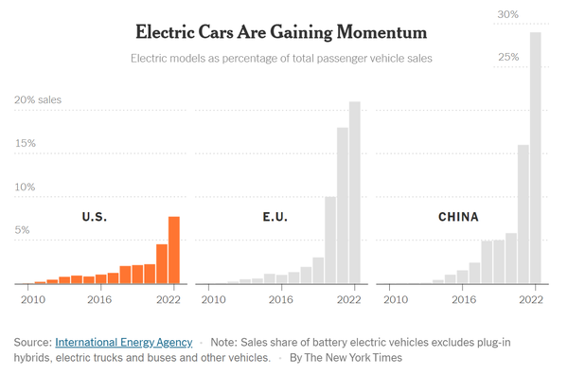

Electric Cars as Percentage of Total Passenger Vehicle Sales

The infographic titled “______________________________” by the *New York Times* with data from __________________________shows three bar charts for electric models as _______________________of total passenger vehicle sales for three geographical areas: ________________, _________________, and _________________ for the years ____ to _____. The orange bar chart shows the percentage of electric car sales in _________________. Next is the percentage of electric car sales in the European Union. Last is the percentage of electric car sales in _________. Each of the three charts displays the ______________ on the vertical axes and ________________ on the horizontal axes. The bars show the For the year 2010, all regions had ___________electric car sales percentages. In 2020, the percentages __________________. In 2022, in China electric car sales percentages _________ to ____ % of total car sales. Overall, China’s market share for electric cars is ________________ than the U.S. and the European Union. This is likely because the population of China is larger than the two other regions combined. However, the other two regions had their highest electric car sales, with ____% of total car sales in the United States, and ____ in the European Union. There are several reasons why electric cars are gaining in popularity. Drivers can save money on gas and maintenance, they are stylish and fun to drive, and they can help reduce carbon emissions, which contribute to climate change. Perhaps the reason why the United States is lagging behind the other two regions is because ____________________________. Overall, the trend shows electric car sales are _____________________ globally.

# You Try It

**Option 1:** Write a paragraph about the following chart.

**Option 2:** If you prefer, you can select a different chart or graph about a topic that interests you. Search online using images.google.com or visit the New York Times Learning Network “What’s Going on in the Graph?” at <https://www.nytimes.com/column/whats-going-on-in-this-graph>, or Statista Daily at <https://www.statista.com/chartoftheday/>

Download the graph or take a screenshot and then include it in your Google Doc or Microsoft Word file.

**Include the steps:**

## Introduce the Chart or Graph

## Describe the Chart or Graph

1. Highlight Key Information
2. Analyze the Data
3. Conclude the Description

**Outline:**

Title:

What is the chart about? (Include the source, dates, and people asked)

What is does the X (horizontal) axis show?

What does the Y (vertical) axis show?

What do the data points (dots) represent?

What does the chart show?

What do you think are some reasons for the data?

What is an overall conclusion that can be made about the chart and its data?

* **Title**: Percentage of young people who say they reach out to a parent at least once a day or a few times a week.
* **Categories on Y-Axis**:
  + **Send texts**: The percentage of young people who communicate with their parents via text messages.
  + **Phone or video-chat**: The percentage of young people who communicate with their parents through phone calls or video chats.
  + **Visit in person**: The percentage of young people who physically visit their parents.
* **Data Points**:
  + **Young Men (Blue Dots)**: The percentage of young men who engage in each communication method.
  + **Young Women (Red Dots)**: The percentage of young women who engage in each communication method.
* **Observations**:
  + Both young men and women predominantly use **text messages** to reach out to their parents.
  + **Phone or video-chat** is the second most common method, with slightly higher usage among young women.
  + **Visiting in person** is less common but still significant.
* **Source**: Pew Research Center (data collected from October 18 to November 5, 2023).

This bar chart visually compares communication habits between genders in their interactions with parents.