Scavenger Hunt Word List

Let’s See How Many You Can Find Today.

Desktop computer

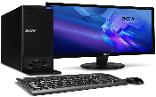

[This Photo](https://www.freepngimg.com/png/51826-desktop-computer-free-png-hq) by Unknown Author is licensed under [CC BY-NC](https://creativecommons.org/licenses/by-nc/3.0/)

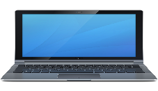

[This Photo](http://www.pngall.com/laptop-png) by Unknown Author is licensed under [CC BY-NC](https://creativecommons.org/licenses/by-nc/3.0/)

Printer

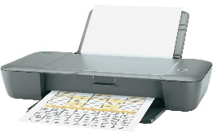

[This Photo](https://driprinter.blogspot.com/2015/06/hp-deskjet-1000-j110a-free-download.html) by Unknown Author is licensed under [CC BY](https://creativecommons.org/licenses/by/3.0/)

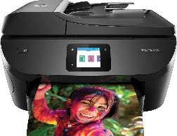

[This Photo](https://technofaq.org/posts/2020/01/laser-printer-guide-in-2020/) by Unknown Author is licensed under [CC BY-SA-NC](https://creativecommons.org/licenses/by-nc-sa/3.0/)

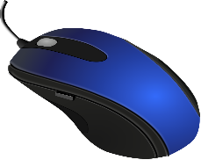

[This Photo](http://www.pngall.com/pc-mouse-png) by Unknown Author is licensed under [CC BY-NC](https://creativecommons.org/licenses/by-nc/3.0/)

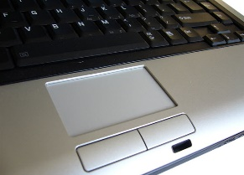

[This Photo](https://positek.net/touchpad-disabled/) by Unknown Author is licensed under [CC BY-SA](https://creativecommons.org/licenses/by-sa/3.0/)

Mouse or Touchpad





[This Photo](https://askatechteacher.com/great-kids-websites/keyboarding-websites/) by Unknown Author is licensed under [CC BY-SA-NC](https://creativecommons.org/licenses/by-nc-sa/3.0/)

Keyboard

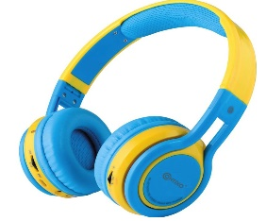

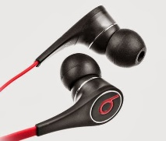

[This Photo](https://yourretailhelper.blogspot.com/2014/03/Beats-by-Dr-Dre-Headphones.html) by Unknown Author is licensed under [CC BY](https://creativecommons.org/licenses/by/3.0/)

Headphones



Mobile Devices



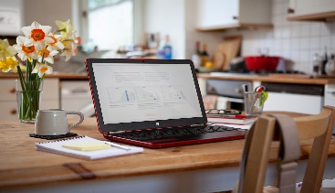

[This Photo](https://blogs.ed.ac.uk/bulletin-magazine/2020/04/14/how-to-set-your-desk-up-at-home/) by Unknown Author is licensed under [CC BY](https://creativecommons.org/licenses/by/3.0/)

Desk/Table



[This Photo](https://www.deviantart.com/pfunked/art/Pen-and-Pencil-124497973) by Unknown Author is licensed under [CC BY-SA](https://creativecommons.org/licenses/by-sa/3.0/)

Pen / Pencils



Writing paper



Calendar