Use Google Docs for Work Cited Page

This guide includes screenshots of the step-by-step process to use the “Citations” feature in Google Docs. The screenshot below is an example of using procon.org as the website to cite.

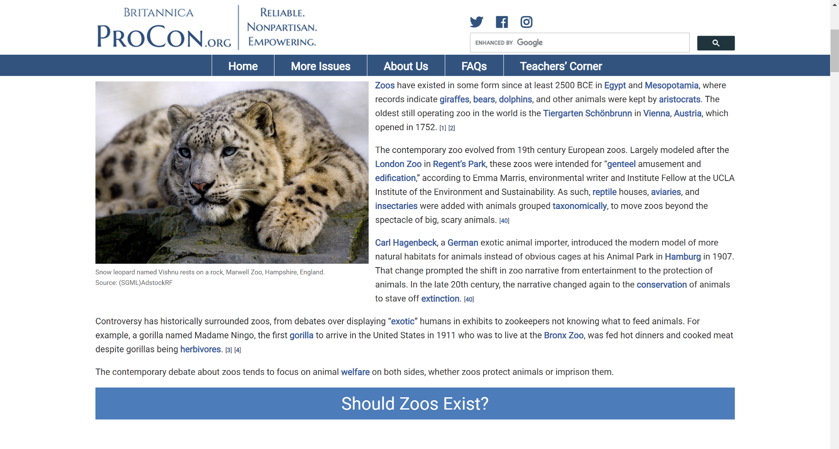

1. On the tool bar, click on “Tools” and select “Citations”.

A screenshot of a computer
with a drop-down menu.

1. When the menu pops up on the right, select your academic format. Then click on “Add citation source”.

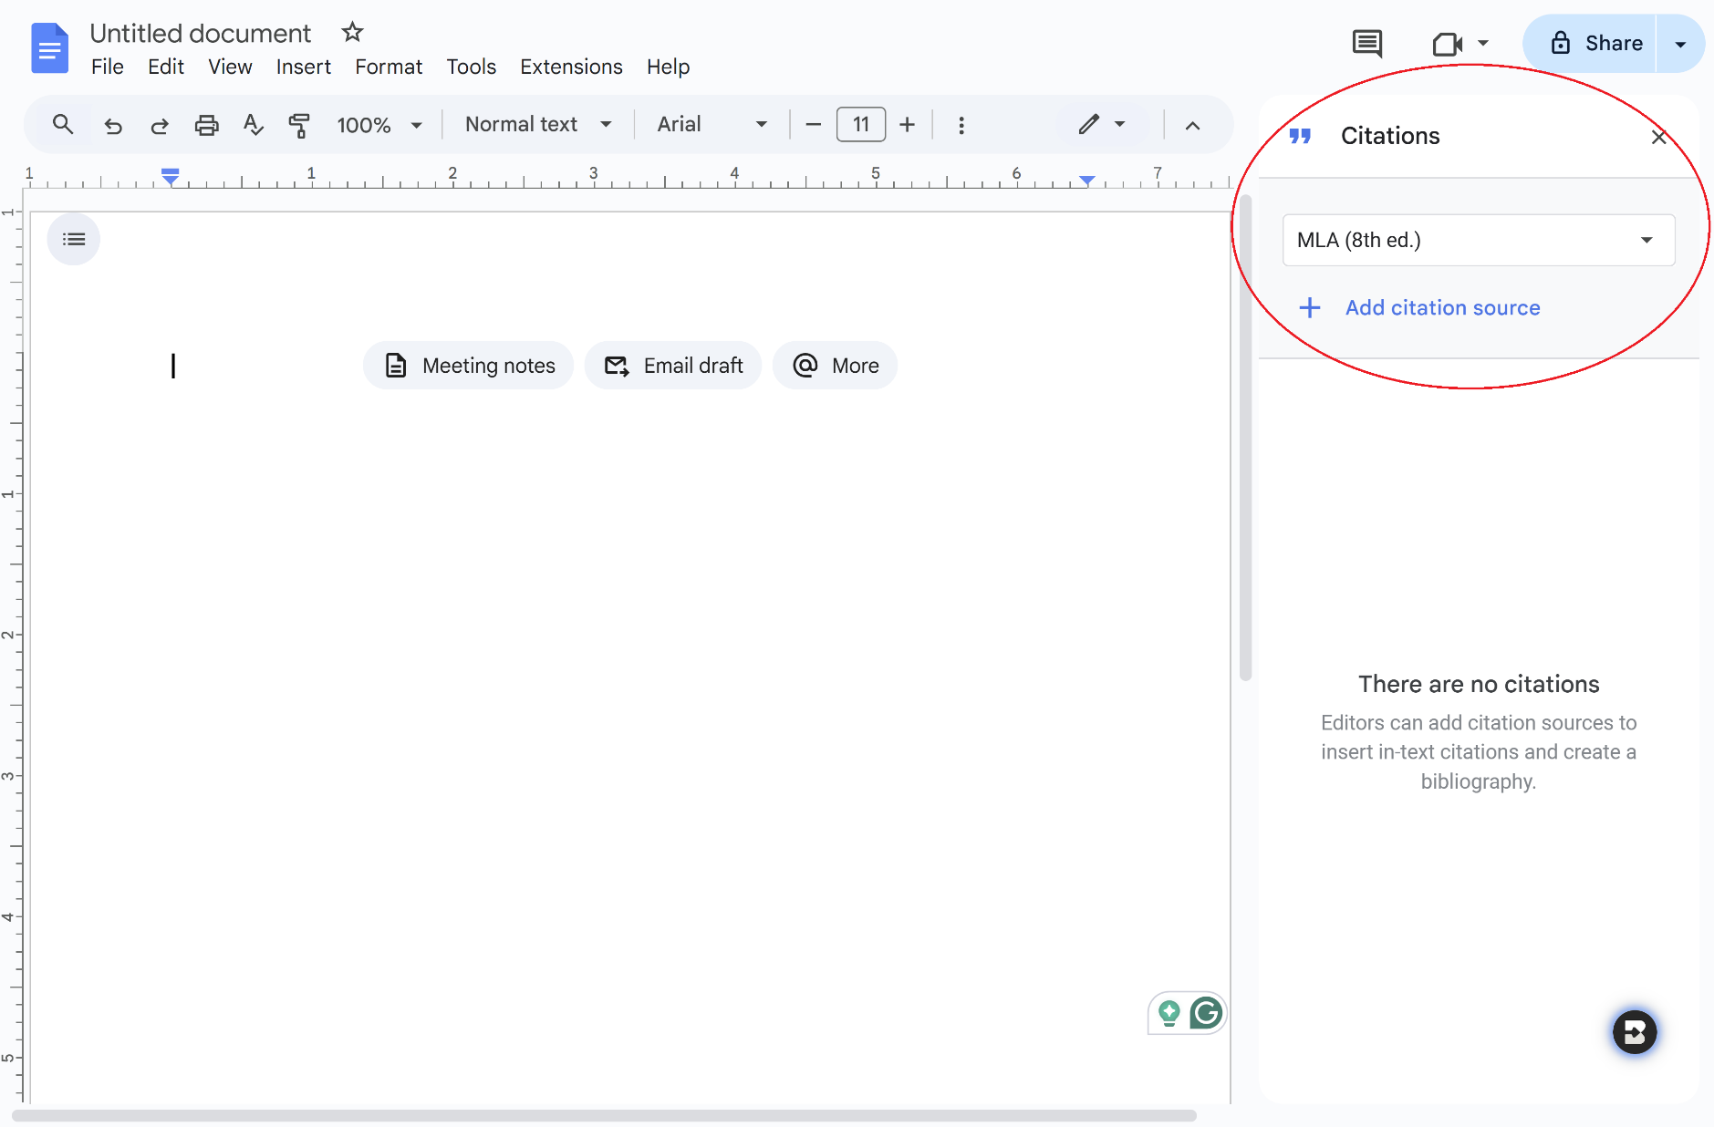

1. Then select “Website” from the dropdown menu.

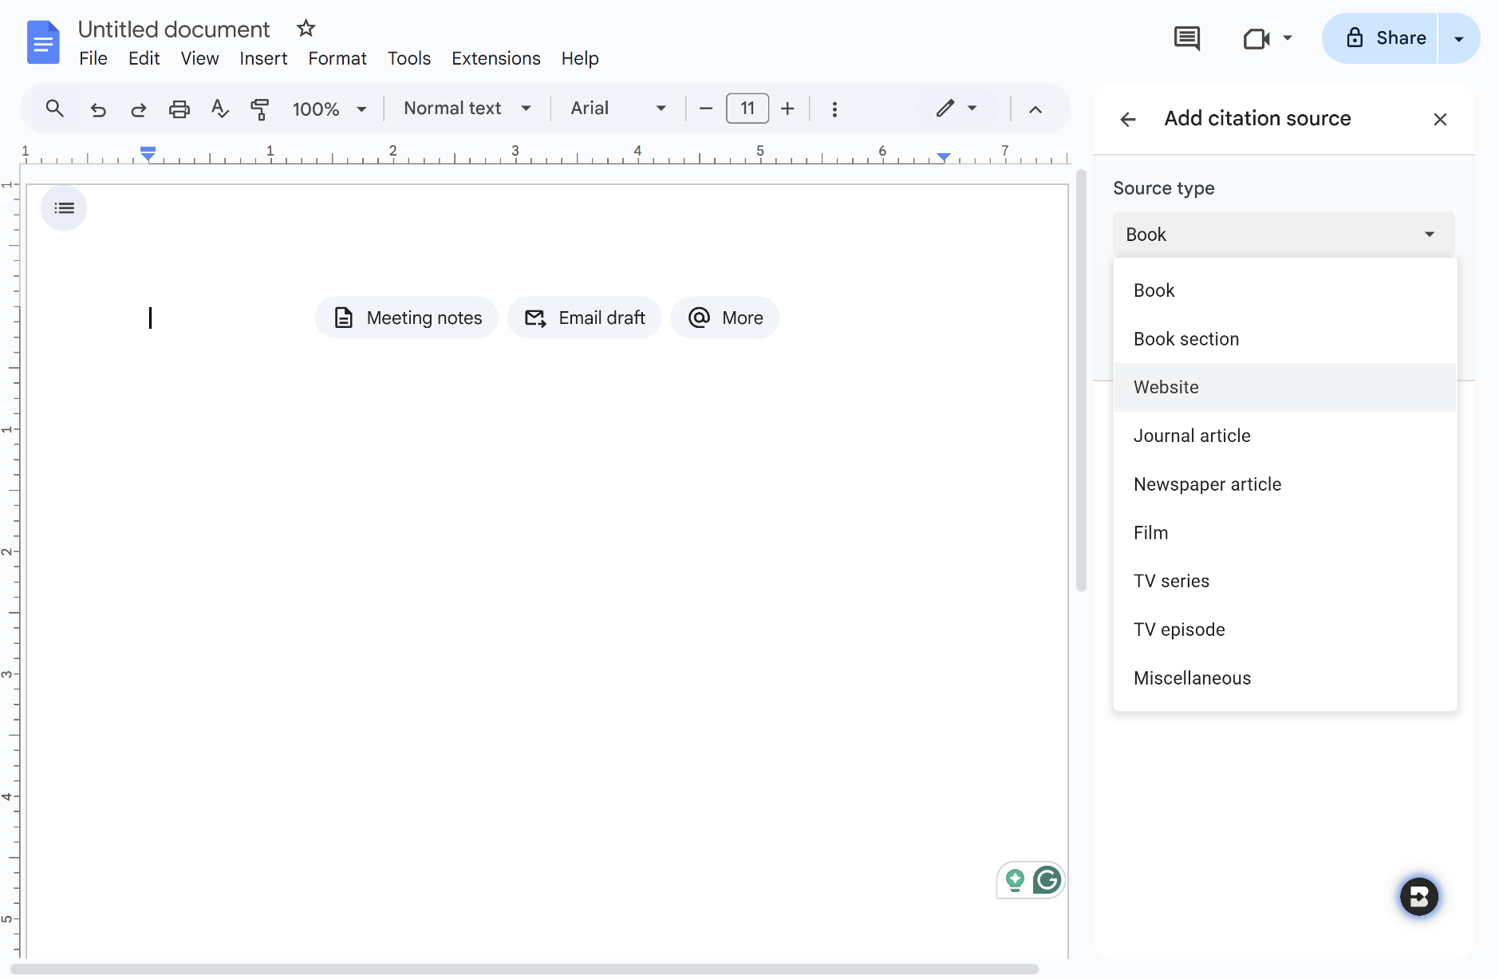

1. Copy the website address and paste it into the blank text field. Then click the search button.

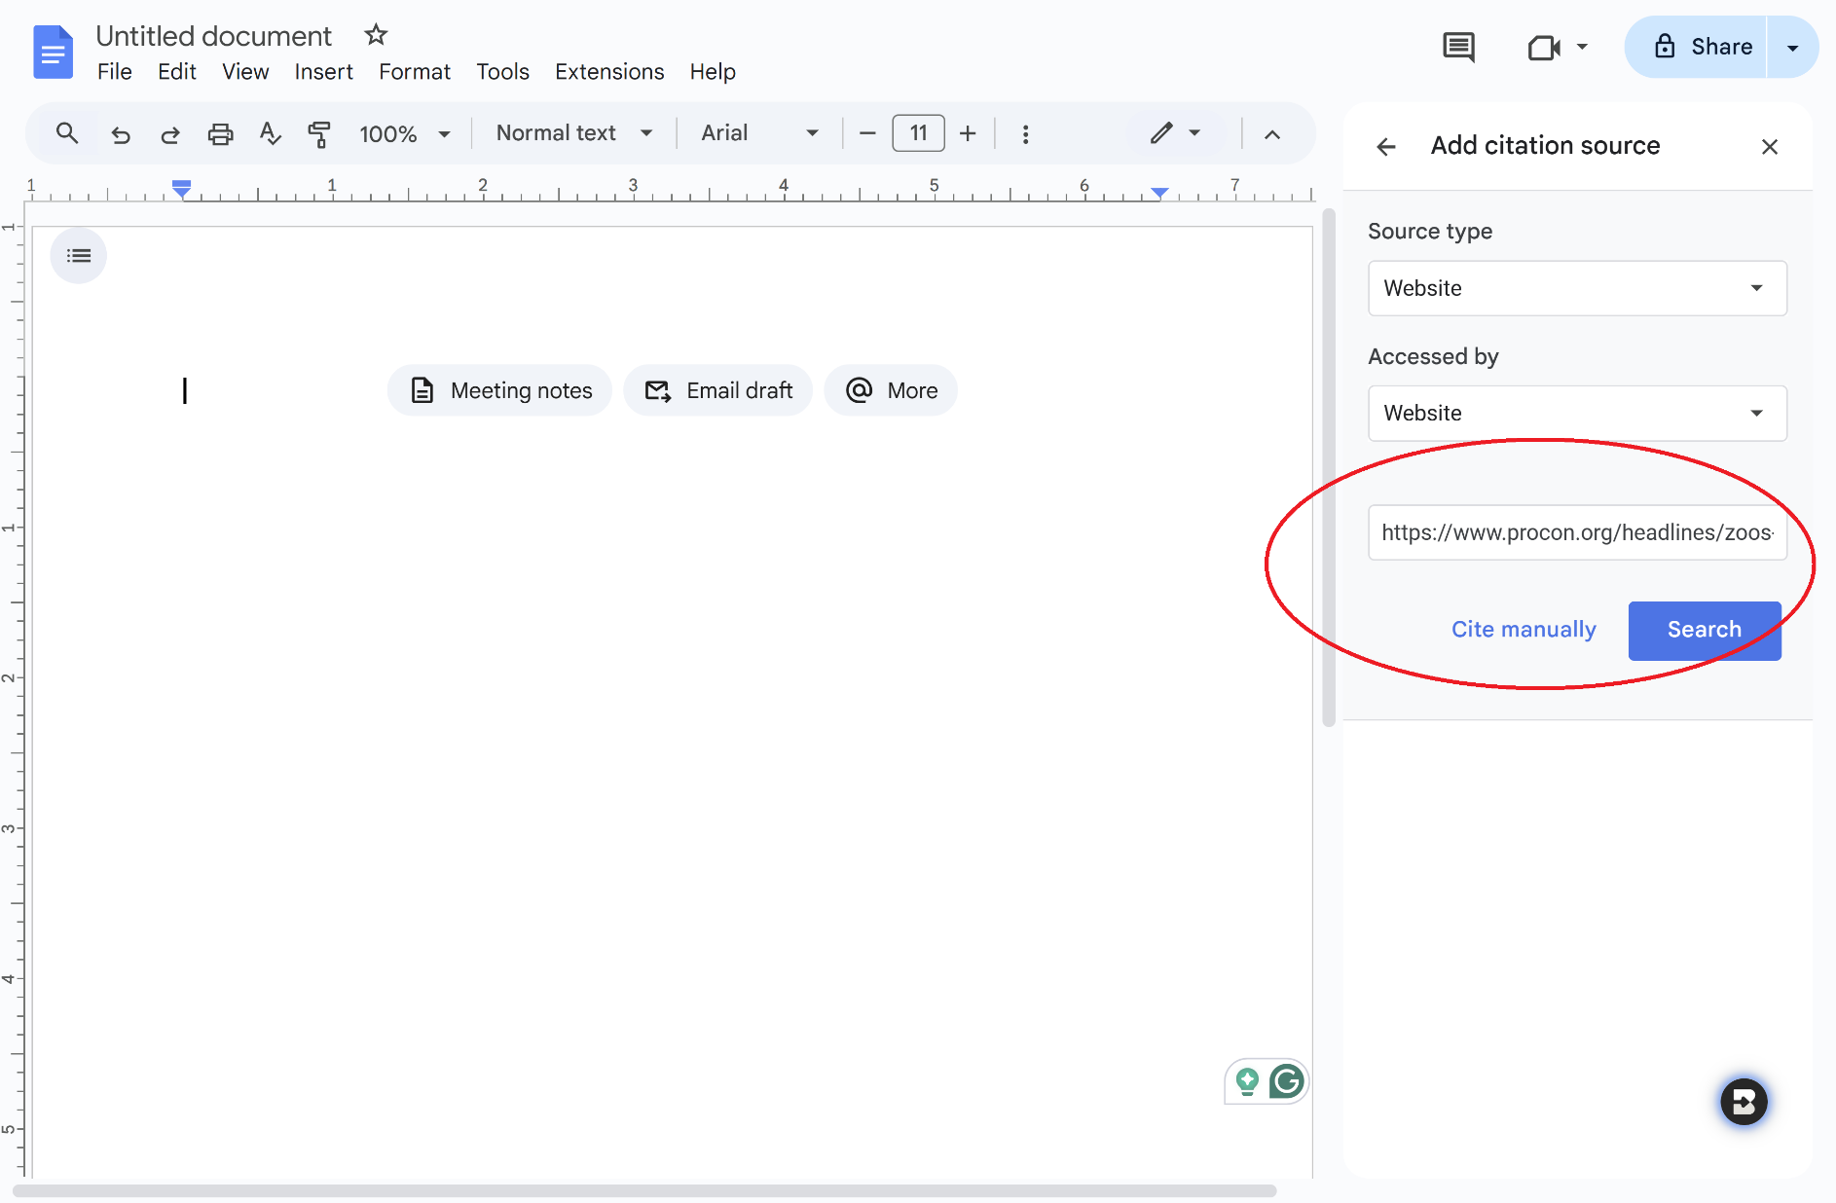

1. Check for accurate information, then click on the continue button.

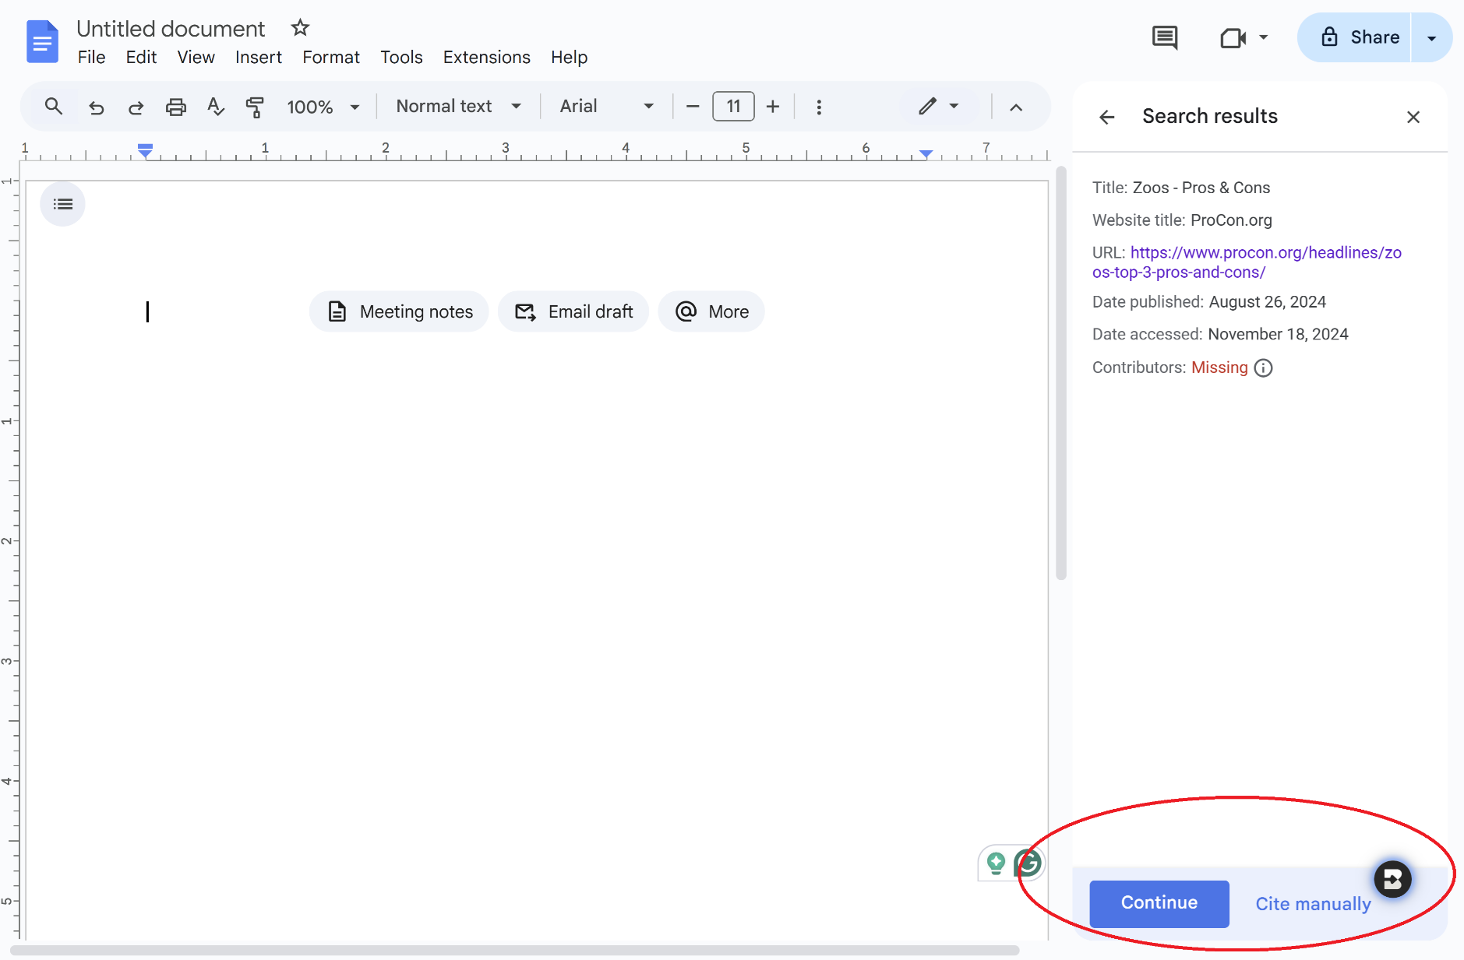

1. Add any missing fields. Then click “Add Citation Source”.

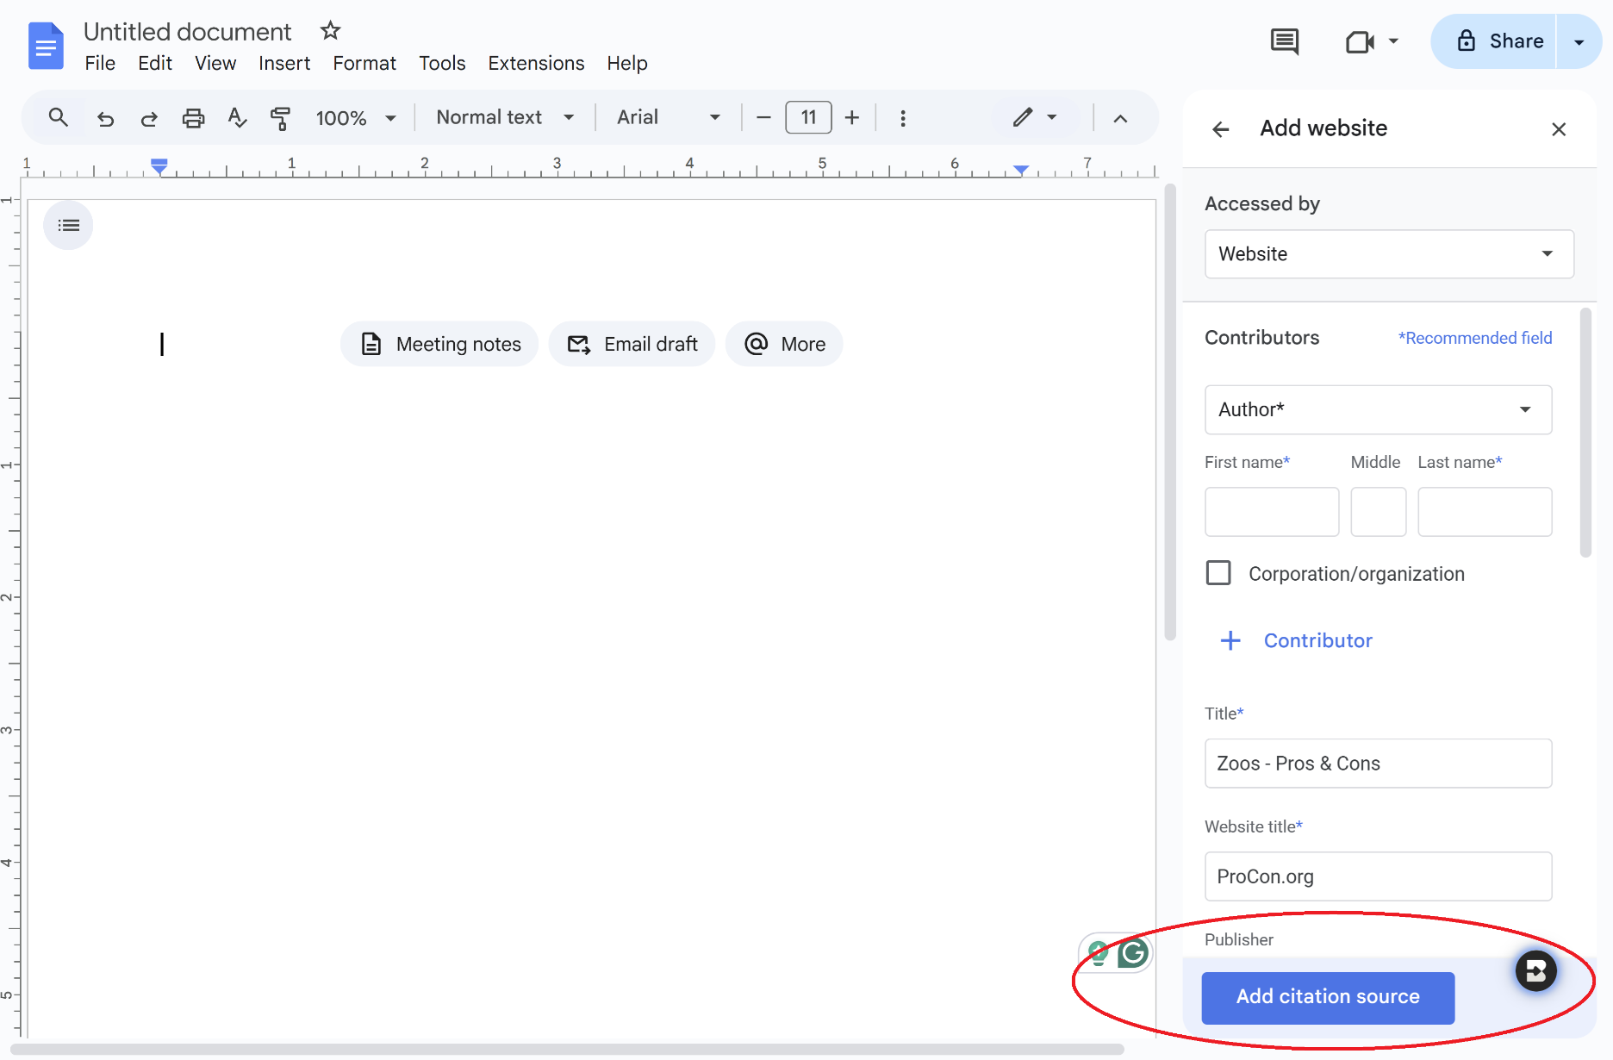

1. You will see a preview of the citation. You can continue adding more sources by clicking on “Add citation source”. Repeat the process above, and the citation list will automatically be sorted in alphabetical order. When all sources are added, click on the “Insert works cited” button on the bottom right corner.

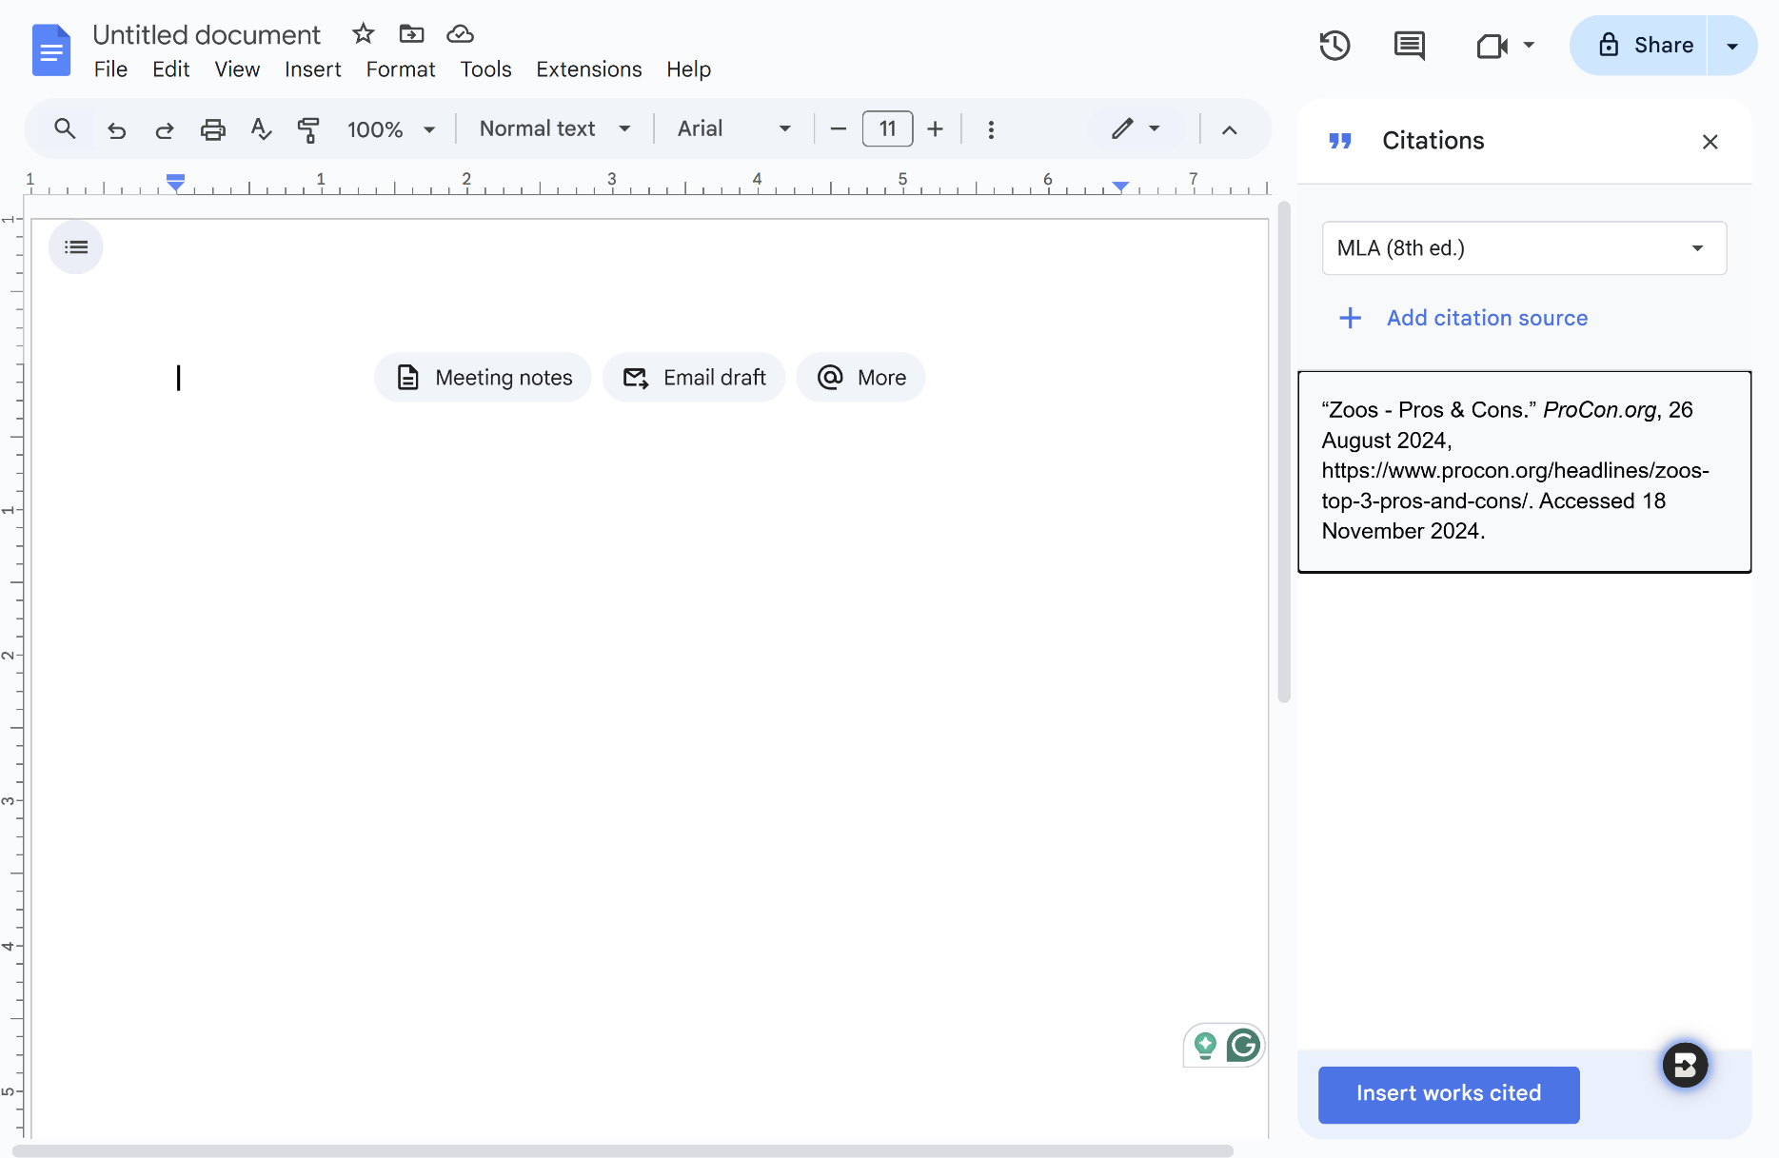

1. The citation should appear on your document.

