Importing the Jotboard background

1.Get an account with Jotboard.

2. Click on the Plus sign for a new board.

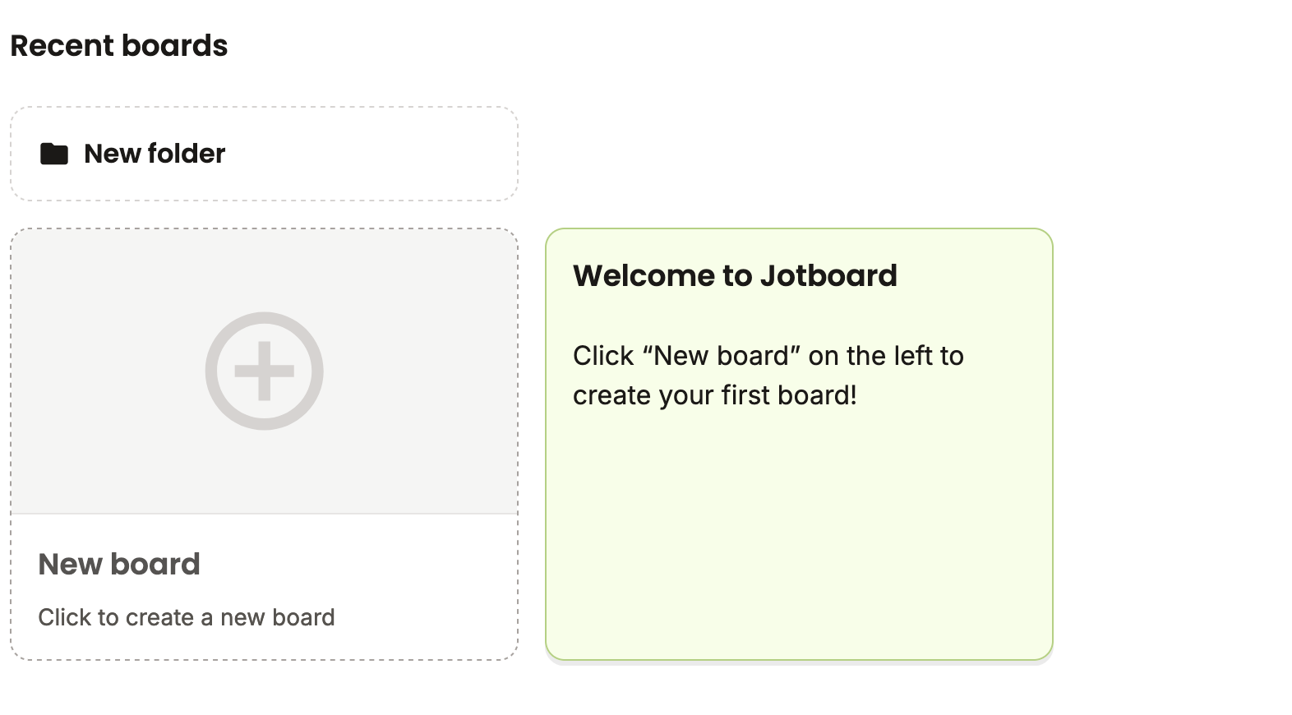

3. Click on Set background

4. Click on upload arrow.

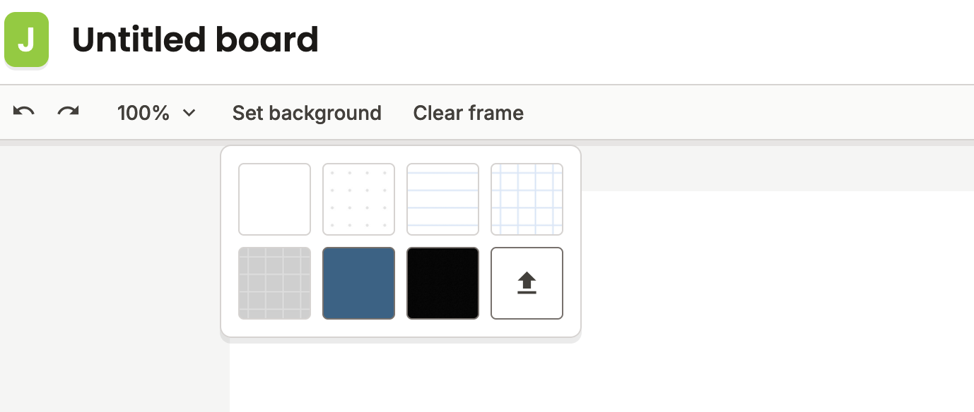

5. Click on Browse file to find the image.

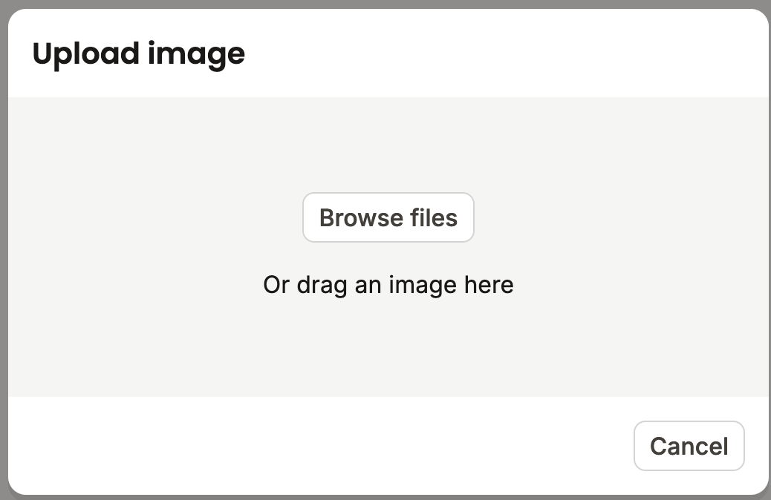

6. Browse your files to find the introduction graphic.

