Vocabulary Matching Exercise

Instructions: Match the Halloween word on the left with the correct definition on the right by drawing a line between them.

Halloween Vocabulary Word | Picture
- Witch _____ | a. 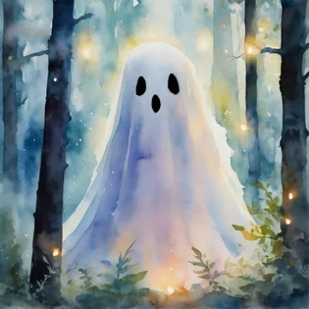
- Ghost ______ | c. 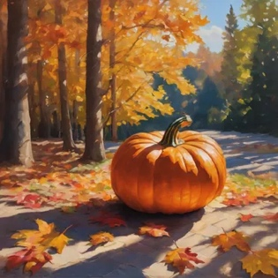
- Costume ______ | d. 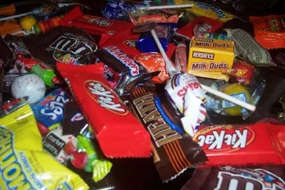
- Pumpkin _____ | e. 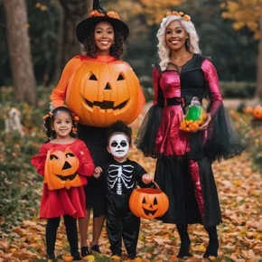
5.. candy _____ | f. 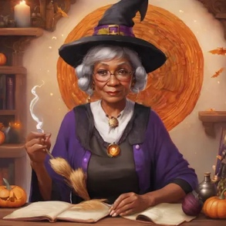

True False: Decide if the sentence is true or false.

- Children say "Trick or Treat" on Halloween.
- Halloween is a holiday celebrated only in the USA.
- People wear costumes to scare ghosts.
- A witch is a person who makes candy.
- Pumpkins are often carved into jack-o'-lanterns.

Answer Key
- Children say "Trick or Treat" on Halloween. (True)
- Halloween is a holiday celebrated only in the USA. (False)
- People wear costumes to scare ghosts. (True)
- A witch is a person who makes candy. (False)
- Pumpkins are often carved into jack-o'-lanterns. (True)

Quiz:
- What do children ask for on Halloween?
  - a) Money
  - b) Candy
  - c) Toys
- What do people often carve on Halloween?
  - a) Apples
  - b) Pumpkins
  - c) Trees
- What do people wear on Halloween?
  - a) Costumes
  - b) Hats
  - c) Shoes
Quiz Answer Key
- What do children ask for on Halloween?
  - a) Money
  - b) Candy
  - c) Toys
- What do people often carve on Halloween?
  - a) Apples
  - b) Pumpkins
  - c) Trees
- What do people wear on Halloween?
  - a) Costumes
  - b) Hats
  - c) Shoes

