My First Day at College

I was feeling a little worried, would I find parking, would I find my building, would I find my classroom? But I made it okay. I sat down in the middle of the room and waited for class to start. The professor was friendly and funny so I started to relax. He went over the syllabus and other class expectations. I am going to be okay; I can do this, I thought. He handed out the names of students in groups with their names and emails. Then he called out our names and we nodded at each other. It was time to go so I gathered up my notebook and headed for the door. As I reached the door, the professor called out to us, “Don’t forget to create a Google Doc and share it with your group.” I froze. I didn’t have any idea what he wanted or how to do it. So much for feeling okay my first day.

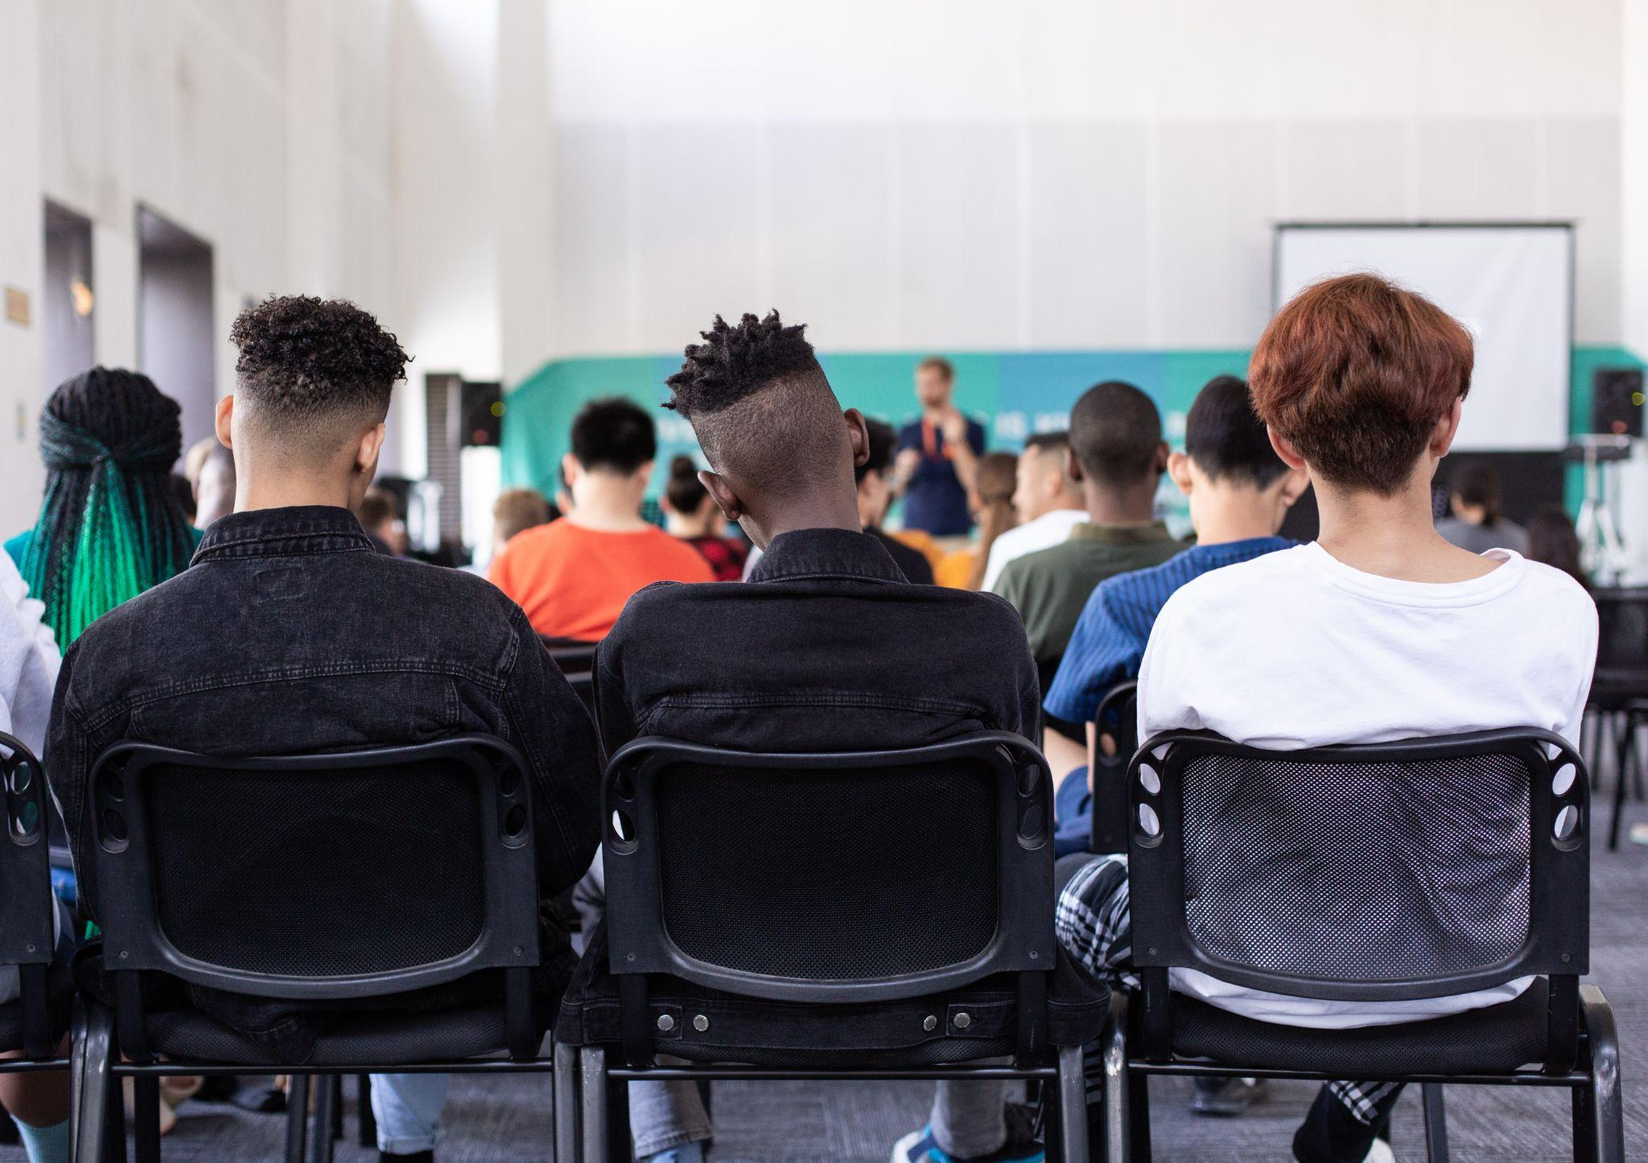

Image sam-balye-w1FwDvIreZU- by unsplash