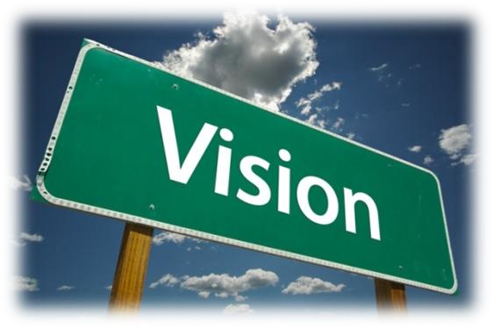
Vision Board Assignment
“We are limited, not by our abilities, but by our vision.”
- Anonymous
What is a Vision Board?
A Vision Board (sometimes called a Dream Board), is a collage of pictures and words depicting an individual’s dreams and goals. The aim of this activity is to help you create your very own Vision Board.
First, let’s review the various categories of goals your Vision Board can include:
- Family and Friends - Personal development and relationships– What skills do I want to develop or improve? What do I want to learn? What relationships do I want to create or improve?
- Education & Career / Work – What do I want to accomplish? What kind of impact do I want to have?
- Health, Fitness, nutrition, and food for the soul– What level of physical fitness do I want to maintain or achieve? What can I do to improve my eating habits? What practices can I partake in that will cultivate my spirituality?
- Material things and time savers– Have fun with this one – have I been dreaming about purchasing a new car or installing the latest home entertainment system? Or do I want to hire help for household duties, so that I can have more time with my family and friends?
- Finances– Do I want to pay down my credit? Do I want to start saving money? Do I want to start investing? What income level do I want to achieve?
- Legacy– What do I want to leave behind? What do I want to be remembered for? How do I want to be remembered?
- Community – How do I want to be involved in your community? Do I want to volunteer? Do I want to meet my neighbors? Do I want to join some groups or organizations?
- Other - ______________________________________________________
Remember, your Vision Board does not necessarily have to include each and every one of these categories. The categories are merely a guideline for the words and pictures your Vision Board can include!

Other things you may want to include:
- A photo of yourself on a billboard, magazine cover, or motivational poster using BigHugeLabs https://bighugelabs.com/
- Your creed or motto - words you live by
- Inspirational quotes
- Your ONE word that defines you or motivates you
- An acrostic poem for your name, which you can make yourself or with acrosticpoem.org. Here’s my example:

K is for Kind, generous to people
R is for Ravishing, an entrancing beauty
I is for Innocent, pure in goodness
S is for Smiling, your smile lights up my day
T is for Thoughtful, considerate towards all
I is for Impartial, fair and unbiased

How to create your Vision Board
Creating your Vision Board is a five-step process:
Think about your goal - get a clear image in your mind of what it is you really want to achieve in your life.
- Create your vision board by adding images and phrases (you draw images, insert online images, take photos and inset them, etc.) that represent your goals.
- Personalize the images - add your name or face wherever possible.
- Display the Vision Board where you can see it every day!! Remind yourself why you are doing this program and what your goal is!
Instructions:
  - First things first. Come up with a list of goals you would like your Vision Board to illustrate.
  - Decide whether this is an activity you’d like to complete on your own, or with others. (Creating a Vision Board with your children or friends for instance, is an excellent way to spend time together and learn more about one another’s dreams and aspirations.)
  - Find images and words that best represent your goals, dreams, and aspirations. Insert the images and text on your vision board and think about how to best arrange them (maybe by category).
  - Place your Vision Board in an area of your home or office that is frequently visited.
  - Look at your Vision Board daily. This will keep your goals and aspirations fresh in your mind and help you retain focus.
  - Your Vision Board has to excite and inspire you!

