Creating Lists in Spelling City
www.spellingcity.com

Step 1: After you have registered, select Login.

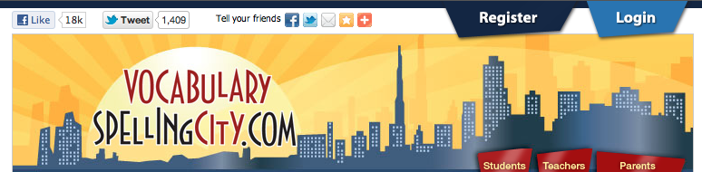

Step 2: Enter your username or e-mail address and password and select Login.

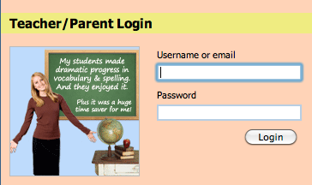

Step 3: Select "Create a New List" under List Management.

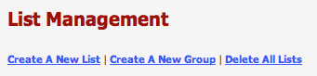

Step 4: Title your list, enter your words (add more words if you would like) and select Save.

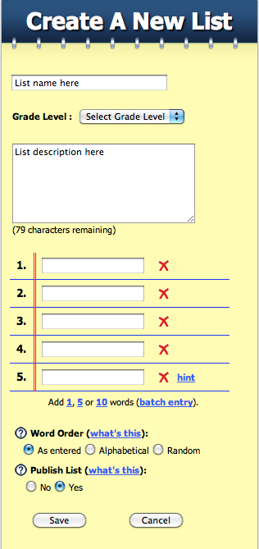

Step 5: Review your word list. Edit definitions and/or sentences if you would like by selecting Edit. When you are finished, select Save.

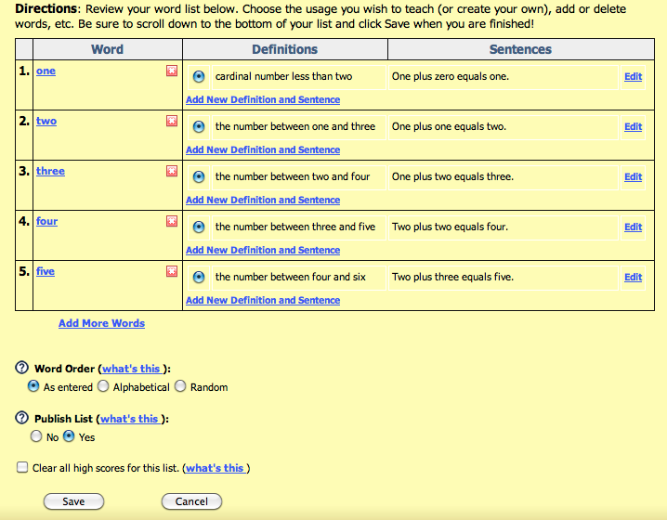

Step 6: Select "Play a Game" to access the learning activities and games list.

