Amazing Places in the USA
For this presentation, you will use the internet to look up information about a national park, monument, natural geographical feature, or architectural site in the U.S. It could be a place you have visited before, a place you have heard of, or a place you would like to visit. Take notes on the information below and then make a presentation. Add information to this our class shared Google Slideshow. Add pictures to your slide and then present your information.
- What is it called?
- Where is it located?
- What is it well known for?
- When was it built/founded/formed/discovered/named?
- How and/or by whom was it built/founded/formed/discovered/named?
- Interesting Facts / Details / Features:
- How is it enjoyed today? By whom?
If you need ideas, see the list on the next slide. See my example on Slide 4. You may add a short video if you like. To add a video, choose Insert - Video - Search in YouTube or enter the URL for a video.
If you need another slide, you may add more. Just don’t change other students’ slides.

Name
Date
Class
Amazing Place in the USA
An Amazing Place in the USA: Devil’s Tower
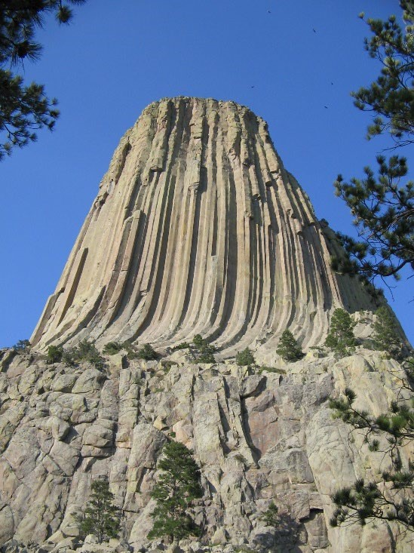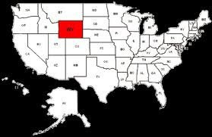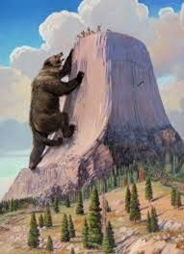
Location: Devil’s Tower is located in northeastern Wyoming.
How it was formed: This 1000-foot tall monolith was formed by molten igneous rock at the throat of a volcano. It was shaped by wind and water over time. The outer layers of the volcano were worn away, and what stands now is the hard core of the volcano.
Interesting facts: According to Native American Legend, Devil’s Tower was formed by supernatural powers. The legend says that seven girls were attacked by bears and ran to the top. The Rock God made the rock grow so that it rose and the girls were safe, while the rock’s gouges on the sides were formed by the bear clawing and scratching at it to try to get to the girls. The legend says that the girls can be seen above the rock on a clear evening as seven bright stars.
Devils Tower was named the United States’ first national monument by Theodore Roosevelt in 1906. Today it is a park enjoyed by rock climbers.

