Using Adobe Spark Express

1. Go to https://spark.adobe.com/ 2. Select “Start Now for Free” to create an account (the next time, just log in).
- Use a Gmail or Facebook account or sign up with another email address or an Adobe ID.
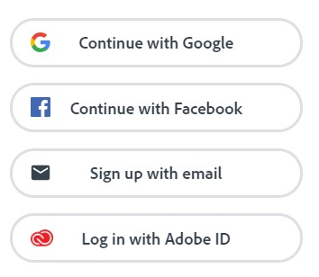
CAPTION: Four ways to sign up for Adobe Spark. Google, Facebook, email, or Adobe ID.
- Select the blue + button to make a new creation in the top left corner. Enter your title (or select the “Skip” button if you don’t have a title yet).
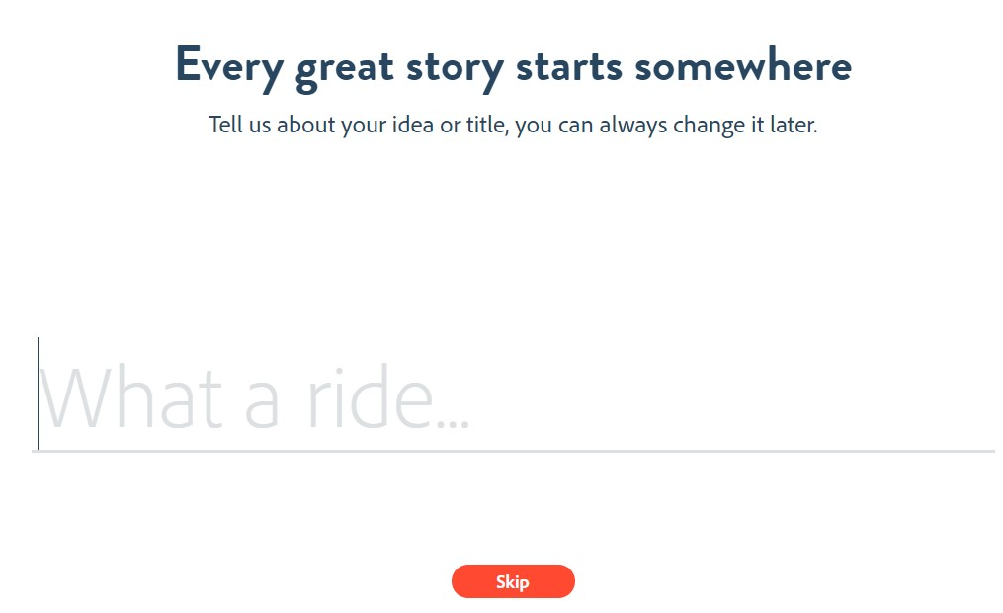
- Select a story template. The options are the following: Promote an Idea,
Tell What Happened, A Hero’s Journey, Show and Tell, Personal Growth, Teach a Lesson, An Invitation, or Make up My Own, depending on what would best fit the task or assignment. When you select a template, sentence prompts appear in your storyboard to help you organize the speech or writing. You can also select “Start from Scratch.”
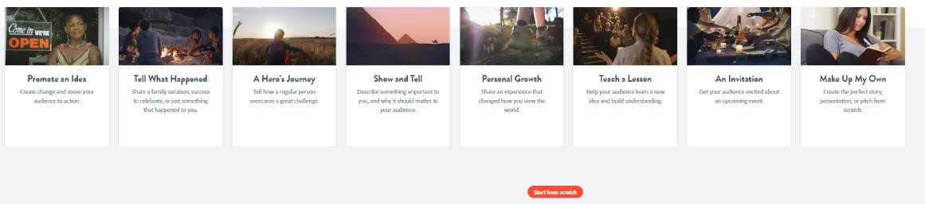
- Watch the short video demo, as desired.
- Add photos. You can upload your own or search from the provided sources.
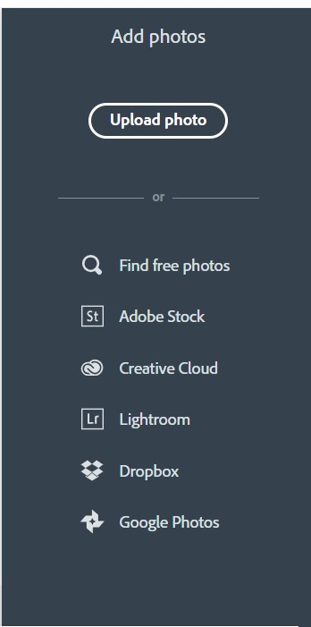
- As you add photos, move the mouse to the next space to the right. You can change the order of photos by dragging them where you want them to be. You can also add videos by selecting the “Video” icon and uploading from your device.
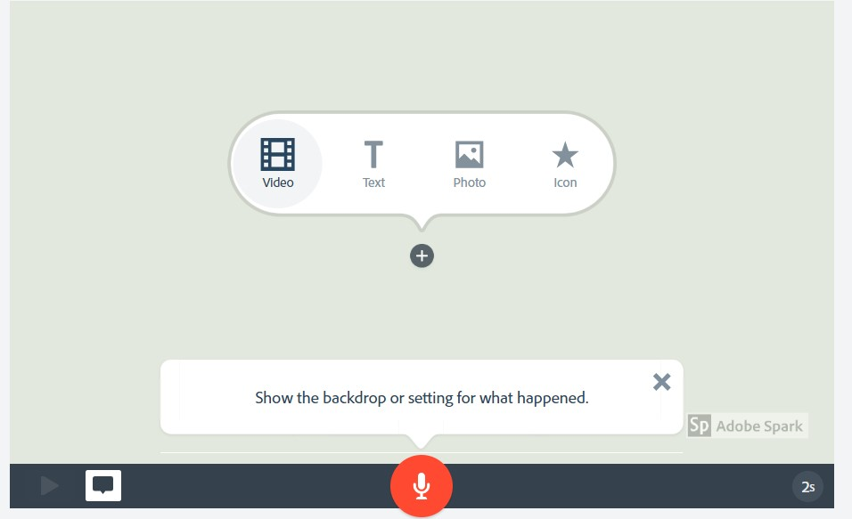
- If you want to delete or duplicate a photo, select the ellipsis (three dots …) on the top right of the photo and select the icon for the action you want to do (delete, duplicate, or play from here).
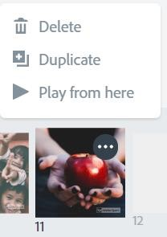
CAPTION: Image options.
- Select a layout for each photo. “Title and Text” would be a good option for the first photo. Type the title of your video in the title area and type your name in the text area.
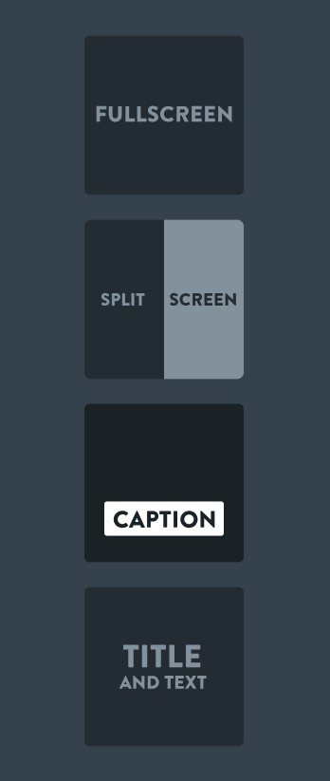
- To add text to a photo, click the + on the photo and select the “T” for text. Type in the text you want to appear with the photo.
- Select a theme (letter font style and transitions). You can move your mouse over each theme to see what it will look like in your video. If you select a theme and decide you don’t like it, just select a new one.
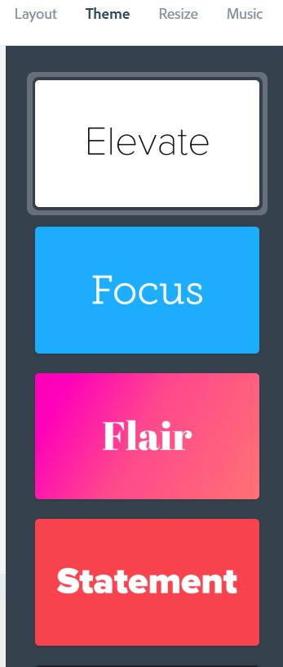
- Select “Resize.” Square may be the best option, but it depends on your photos.
- Next, select the music. You can also upload your own music by selecting “Add my music.”
- Press the play button under your video preview area to hear the music.
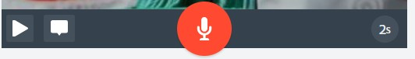
- Now you are ready to record your voice. Have ready what you want to say for each photo. Select the microphone icon and hold it down while you speak. You may see a message asking you to give permission to access your microphone. Select “Yes” if so. If you make a mistake or don’t like your recording, just repeat.
- You will know if your voice has been recorded if you see sound bars on each side of the microphone icon:
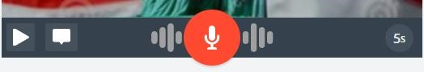
- Note that you can only record 30 seconds of voice narration per image. You can change the length of time for the image by selecting the circle at the bottom right and then move the slider to change the duration. If you want to speak about an image for more than 30 seconds, just add the image to the timeline more than once and break up the narration into two or more parts.
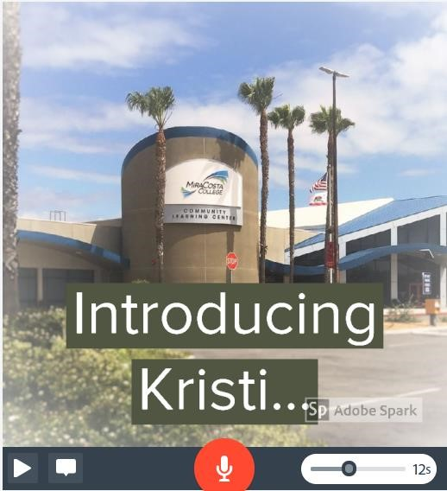
- Preview your video by selecting the preview button at the top.
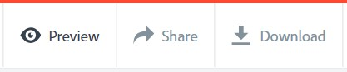
- To go back to your video to make changes, select the X in the top right corner.
- To share your video, select “Share” at the top. Add a title if you don’t have one and optionally a subtitle. Select a category (Education) and then the “Create link” button will be activated. (You can also download your video as an MPEG-4 movie to the desktop of your computer by selecting the download button).
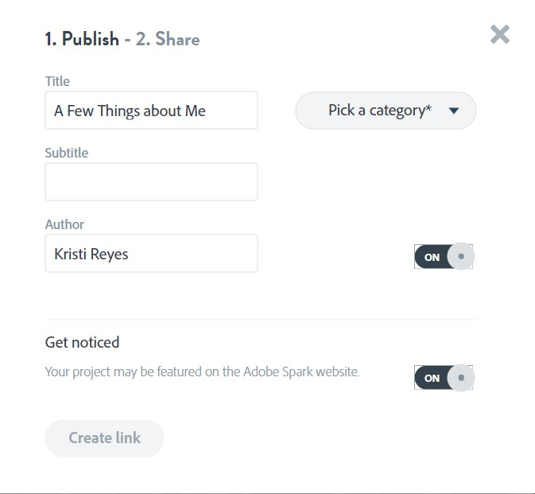
- Wait for your project to render.
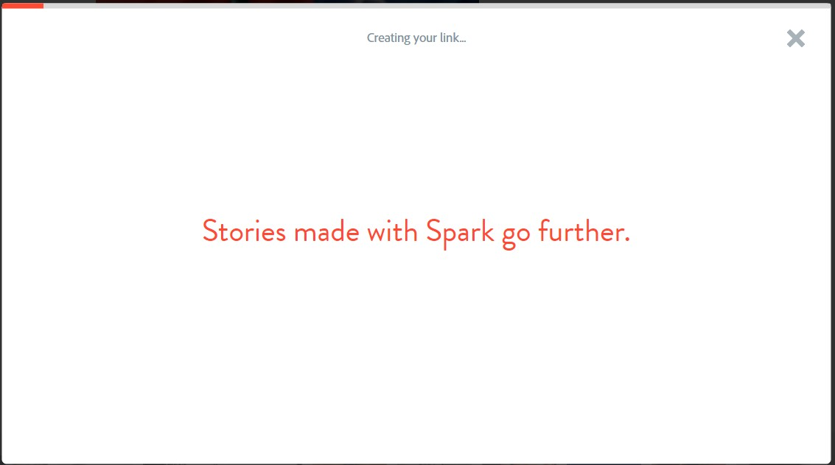
- After the video has rendered, you will see sharing options.
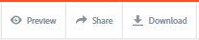
- Your project will then have a URL that you can share on social media, email, or embed in a website. Select “Email” and type in your teacher’s email address. You will also receive an email at the address you used to create your account from Adobe Spark with a link to your project.
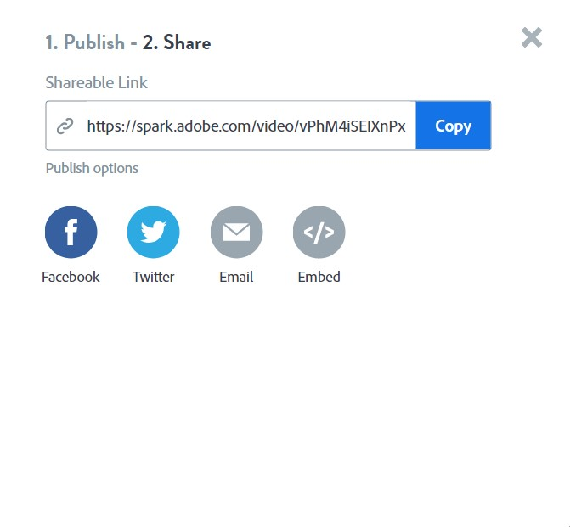
When you log back in to Adobe Spark, your project will be visible, and you can select it to edit at any time. You can also download the videos for offline viewing.

