Narrate a PowerPoint Slideshow (versions 2013 and newer):
- Open the PowerPoint.
- Select Slide Show.
- Select Record Slide Show.
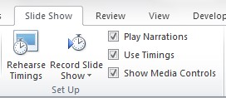
- Select Start Recording.
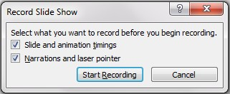
- Talk and click -- talk and click -- talk and click (advance through the slides, taking about each one – make sure to leave a little bit of time after your click to begin talking and don’t advance to the next slide too fast because your voice may get cut off).
Note: You can also record your voice on each slide separately by selecting the Insert tab, and then Audio, and Record Audio.
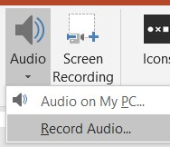
- Press the [F5] key to listen. If you like it, go to step number 7.
If you want to record again, press the undo icon (top left corner) or press the control key and the letter Z at the same time [Ctrl] + [Z] and repeat all the steps starting with step 2.
- Resave your PowerPoint.
Select the save/diskette icon in the top left corner or save by pressing down the control key and the S key at the same time. [Ctrl] + [S]
Narrate a PowerPoint Slideshow (versions before 2013):
- Open the PowerPoint.
- Select Slide Show
- Select Record Narration
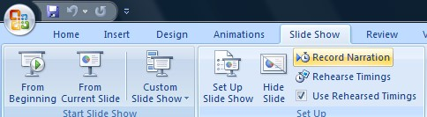
- Select OK
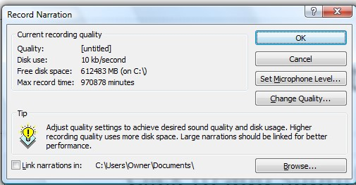
- Talk and select -- talk and select -- talk and select
- At the end, when you see a black screen, select one more time.
- Select Save
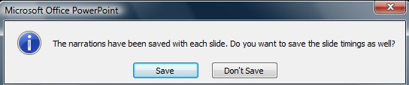
- Resave your PowerPoint. Press down the control key and the S key at the same time.
[Ctrl] + [S]
Export a PowerPoint Slideshow as a Video (versions 2013 and newer)
- Select File > Export.
- Select “Create a Video” on the Export menu.
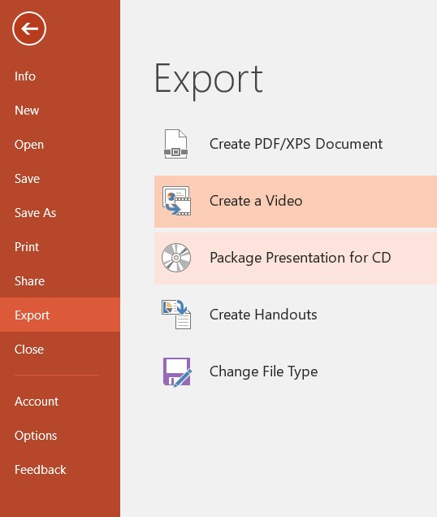
- Select the “Create Video” button.
- Give the video a name in the “File name” area. Select where to save the video and the preferred video type (MPEG-4 Video, compatible with most devices, or Windows Media Video, most compatible with Windows devices). Select the “Save” button.
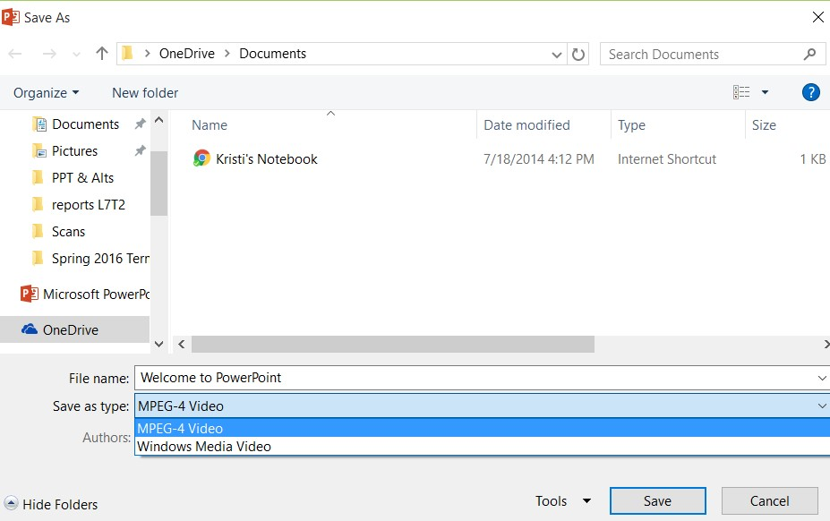
- Wait for the video rendering to be complete by viewing the progress bar at the bottom of the PowerPoint window.
- Preview the video. If there are changes to make (to transitions, timings, etc.), return to the PowerPoint file, make changes, re-save, and repeat the video export.
Note: For Versions 2010 and Older, see the “Turn your presentation into a video article” at the Microsoft Support site.

