Personal Seal Project

**Directions:** In this unit, you will learn about symbolism while working on your writing skills. Use the Web site URLs provided to complete the tasks that follow.

**Task 1: Learn about symbolism in the California State Seal.**

View the image at [http://tinyurl.com/pgmtdu7.](http://tinyurl.com/pgmtdu7) Do you know or have any ideas about what the images represent? If so, write what you know or think below:

Next, learn more about the symbolic meanings of the images on the California State seal by watching this video: [http://youtu.be/edfHpTfn2m0.](http://youtu.be/edfHpTfn2m0) Words in the video that may be unfamiliar to you are the following:

* allude to (verb) = to make a reference to something or someone; to mention something or someone in an indirect way. Example: By imitating my pronunciation, my instructor alluded to the fact that my Spanish is bad.
* sheaf (noun) = a bundle or group of grain stalks (like hay) tied together Example:

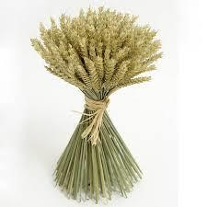

Fill out the table below as you watch. Write the image in the California seal that corresponds to each symbolic meaning or write the symbolic meaning for images. Watch the video as many times as you need to.

| Image | What it symbolizes |
| --- | --- |
|  | Greek Goddess of wisdom and war |
|  | official state animal |
|  | wine production |
| sheaves of greenery and grape vine |  |
| gold mine |  |
| ships |  |
| “Eureka!” - Greek word for “I have found it!” |  |
|  | one year before California joined the union |
| 31 stars |  |

**Task 2: Expand your vocabulary.**

Learn four or more words that are synonyms for the verb "symbolize." Open the URL [http://www.snappywords.com,](http://www.snappywords.com/) a visual thesaurus, or the thesaurus at [http://www.thesaurus.com](http://www.thesaurus.com/) and enter the word "symbolize.” Make sure to choose only verbs. Write down a minimum of four verbs that mean the same as “symbolize” below. You will use these words in your writing assignment.

1. ________________________________
2. ________________________________
3. ________________________________
4. ________________________________

**Task 3: Learn about the Great Seal of the United States.**

Have you ever seen the Great Seal of the United States? Like state seals and other countries’ seals, it has imagery that represents the history and values of the country. Before you read about the symbolism on the Great Seal, see what you already know and prepare for the reading by completing the pre-reading prediction table on the next page.

**Pre-reading / prediction.**

Read each sentence. If you think the sentence is true, write T in the table. If you think the sentence is false, write F in the table.

| **#** | **Sentence** | **True or False?** | **I was correct** | **I was wrong - correction:** |
| --- | --- | --- | --- | --- |
| 1 | The Great Seal of the United States is displayed in the White House in Washington, D.C. |  |  |  |
| 2 | The Great Seal was designed by the first colonists (the Pilgrims), who came from Europe to America in 1620. |  |  |  |
| 3 | There is an eagle on the Great Seal. |  |  |  |
| 4 | There is a dollar on the Great Seal. |  |  |  |
| 5 | There are Greek words on the Great Seal. |  |  |  |
| 6 | The Great Seal has the colors of the United States flag on it: red, white, and blue. |  |  |  |
| 7 | The first president of the United States, George Washington, appears on the Great Seal. |  |  |  |
| 8 | According to an American superstition, the number 13 is unlucky, so this number does not appear on the Great Seal or any other emblems or items that represent the United States. |  |  |  |

**Check your predictions.**

Read the online article about the Great Seal of the United States at <http://www.statesymbolsusa.org/symbol-official-item/national-us/state-seal/united-states-seal>If you were correct about your predictions, check the “I was correct” box in the table.

If you were incorrect, don’t worry! The purpose is to focus your reading. In the “I was wrong” column, change the sentence to make it correct or write a sentence from the article that gives the correct information.

Read the article again to answer comprehension questions.

View the questions below. You may paste URL for article into the VoyCabulary site at [http://www.voycabulary.com](http://www.voycabulary.com/) to re-read the article with vocabulary support (double-click on words in the text you do not understand in order to see a definition), or you may use an online learners dictionary [http://www.learnersdictionary.com](http://www.learnersdictionary.com/) to enter words you do not know and see definitions. Enter your answers to the questions.

1. Where is the Great Seal of the United States typically seen? (there is more than one answer)
2. Was the seal created before or after the United States gained independence from England?

How do you know? Give specific evidence from the text.

1. “The symbols of the seal reflect the beliefs and values that the Founding Fathers wanted to pass on to their descendants.” Who are the “Founding Fathers,” in your own words? Explain in your own words who the “descendants” were.
2. What do the olive branch and arrows represent?
3. What do these colors represent?
   1. red =
   2. white =
   3. blue =
4. What is the meaning of the constellation?
5. What is the significance of the number 13 for the United States? Besides the Great Seal, on what other national emblem is the number 13 featured?
6. Overall, to what do the symbols on the reverse of the Great Seal (pyramid, eye, scroll) refer?
7. Find three or more words in the article that are synonyms for the verb “symbolize” (note: some may be the same or different from those you listed in Task 3.
   1. ______________________________
   2. ______________________________
   3. ______________________________

**Task 4: Create a personal seal.**

For this project, you will design a personal seal in PowerPoint or any design software you know (Photoshop or Paint, for example) with two to four images that symbolize you: your character, your work, your goals or dreams, your culture/traditions, etc.

First, choose two to four things to symbolize you. The symbols can be animals, nature scenes, places, or objects.

In the table, write key words under “Something about Me.” In the “Image to Use…” column, write words for images that can be used to symbolize that information about you. For example, if you love playing soccer, you can write: “I love soccer” and the image can be a “soccer ball.”

| Something about Me | Image to Use to Symbolize this Information |
| --- | --- |
|  |  |
|  |  |
|  |  |
|  |  |
|  |  |

Second, design your seal. Sketch your ideas here:

Then use PowerPoint, Google Slides, or Google Draw to create your seal.

Instructor’s Sample Seal:

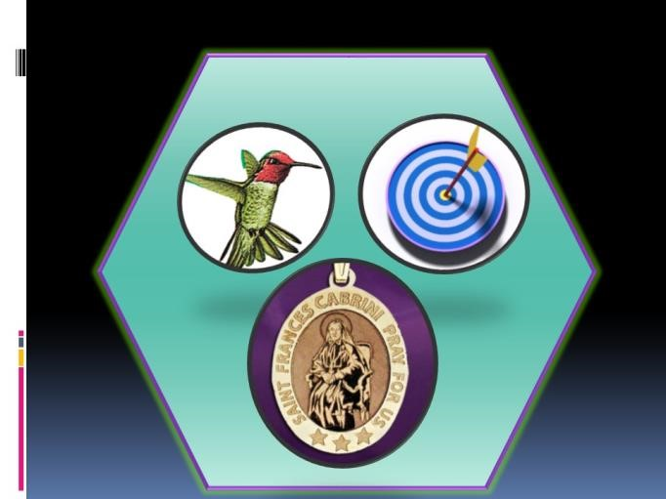

**Task 5: Write a paragraph explaining your personal seal.**

Explain how the images in your personal seal represent the person you are. Make sure to use the following:

❏ a heading in the top left with your name, the date, class, and assignment

❏ a centered title

❏ indented first line, double-spacing

❏ a topic sentence to introduce your topic

❏ a brief description of each image of your personal seal followed by an explanation of how it represents you

❏ a variety of synonyms for the word “symbolize” (note: see the words you wrote in Task 3 and Task 4, question #9)

❏ transitions between sentences (first, second, next, another, finally, last, in conclusion, to conclude)

❏ a concluding sentence

Instructor’s sample:

My Personal Seal: Symbols of the Person I Am

My personal seal has three symbols that represent who I am. First, the hummingbird symbolizes my character and work ethic. I am a very hardworking person, and, like a hummingbird, I like to be efficient and do things quickly. People often tell me to slow down and say, “You are always running!” However, same as this little bird, I prefer to be busy and productive. The second symbol on my seal that shows my character is a dartboard with an arrow hitting its target. This image represents my drive and motivation to do everything the best I can. I am not a perfectionist, but I do strive for quality in my activities, relationships, and work. Finally, the last symbol on my personal seal is the image of Saint Xavier Cabrini, who was also known as “Mother Cabrini.” She is the patron saint of immigrants and was the first American citizen to become a saint. She was sent by the Pope of the Catholic Church to New York in 1889 to help Italian immigrants in the United States there. She ran a hospital and later worked and then died in Chicago, Illinois. Although I am no saint, I have one thing in common with Mother Cabrini: I chose as my career work that helps immigrants in the United States because I respect people who have the courage to leave their native countries to live in a foreign place, whether for adventure, love, family unification, or necessity. In conclusion, these symbols signify the person I am at this time in my life.

Use this outline for your first draft:

Title: _________________________________________________________________

Topic Sentence: ________________________________________________________

_____________________________________________________________________ _____________________________________________________________________

First symbol description:_________________________________________________________________ __________________________________________________________________________

Explanation:

__________________________________________________________________________ __________________________________________________________________________

Second symbol description:_________________________________________________________________ __________________________________________________________________________

Explanation:

__________________________________________________________________________ __________________________________________________________________________

Third symbol description:_________________________________________________________________ __________________________________________________________________________

Explanation:

__________________________________________________________________________ __________________________________________________________________________ Conclusion:

__________________________________________________________________________ __________________________________________________________________________

Type your draft on Google Docs and share your file with me. I will provide comments for revision.

**Task 6: Introduce yourself to the class using your personal seal in an oral presentation.** Make an in-class oral presentation to introduce yourself to your classmates using your personal seal as a visual aide and your paragraph as the basis for what you will say. Feedback on presentations will be provided using a simple checklist.