Emoji Story
Team 1:

Team 2:

Team 3:

Emoji Story

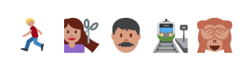
Team 1:

Team 2:

Team 3:

Emoji Story
Team 1:

Team 2:

Team 3:

Emoji Story

Team 1:

Team 2:

Team 3:

Emoji Story

Team 1:

Team 2:

Team 3:

Emoji Story

Team 1:

Team 2:

Team 3:

Emoji Story

Team 1:

Team 2:

Team 3:

Emoji Story

Team 1:

Team 2:

Team 3:

Emoji Story

Team 1:

Team 2:

Team 3:

Emoji Story

Team 1:

Team 2:

Team 3:

Emoji Story

Team 1:

Team 2:

Team 3:

Emoji Story

Team 1:

Team 2:

Team 3:

Emoji Story

Team 1:

Team 2:

Team 3:

Emoji Story

Team 1:

Team 2:

Team 3:

Emoji Story

Team 1:

Team 2:

Team 3:

Emoji Story

Team 1:

Team 2:

Team 3:

Emoji Story

Team 1:

Team 2:

Team 3:

Emoji Story

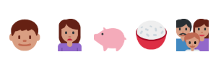
Team 1:

Team 2:

Team 3:

Emoji Story

Team 1:

Team 2:

Team 3:

Emoji Story

Team 1:

Team 2:

Team 3:

Emoji Story

Team 1:

Team 2:

Team 3:

