Make a Calendar Using Microsoft Word
For this assignment you will create a calendar for the current month.
To do this assignment you will:
- Access a template on Microsoft Word
- Add five events on the calendar
- Add five graphics to the calendar

Access a Template
- Open Microsoft Word
- Click on File at the top left. Click on New. Type in calendar under Search for online templates. Scroll down to the monthly/weekly calendar. Click on create.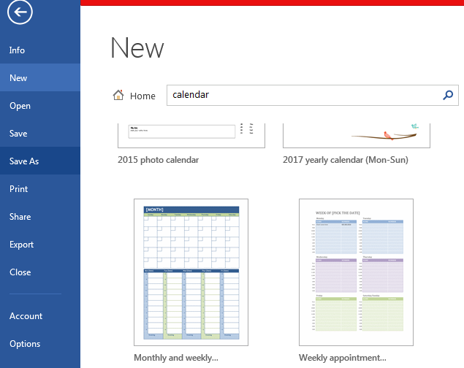

Making a Calendar
- Fill in the month and add your name. To add events, click in the date box and type.
To add graphics, select Insert on the menu bar. Click on Online Pictures. Type in what you want a picture of. Images have been gathered under Creative Commons so you can use them, Insert.
- Print your calendar.