Name __________________________________________ Date ________________

http://www.sense-lang.org/typing/tutor/keyboarding.php

Fill in the keyboard:

[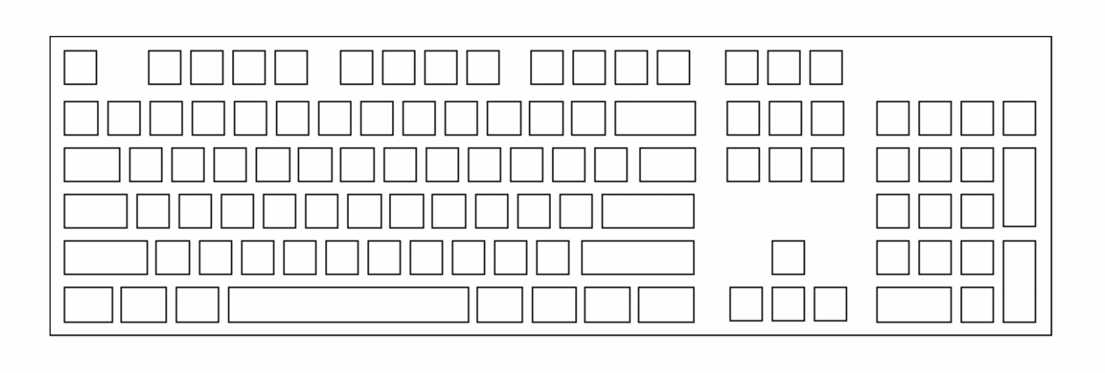](http://www.google.com/url?sa=i&rct=j&q=&esrc=s&source=images&cd=&cad=rja&uact=8&docid=n0e1etUn9p4IhM&tbnid=2g0ycgGxjyZn6M:&ved=0CAUQjRw&url=http%3A%2F%2Fwww.minus40.info%2Fice%2Fcanadiankeyboard.html&ei=god7U9HxNc3voASX_4G4BA&bvm=bv.67229260,d.cGU&psig=AFQjCNGldxsJwjiJ6QLBGiAfMiI45gvi2Q&ust=1400690919669651)

What are the four tips they present:

1) ____________________________________________________________________________

______________________________________________________________________________

2) ____________________________________________________________________________

______________________________________________________________________________

3) ____________________________________________________________________________

______________________________________________________________________________

4) ____________________________________________________________________________

______________________________________________________________________________