# Blogger

A blog is a web-log. It is an online forum for ideas and communication. They are great for collaboration and sharing.

1. Use your Google account or create a new one.

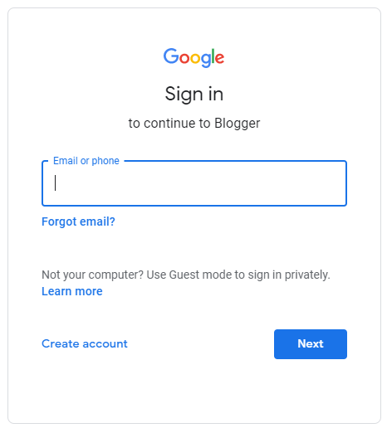

1. Click on Create Blog and give your blog a name and a URL.

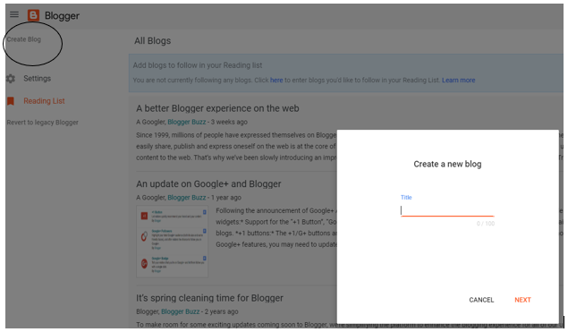

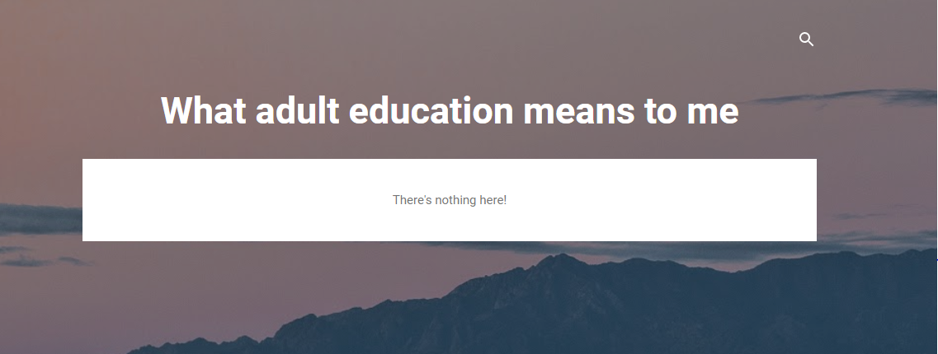

1. If you click on the big plus sign at the bottom of the screen you create a post:

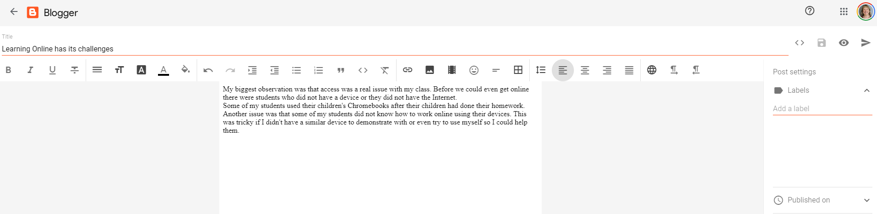

1. On your dashboard you can see your posts. If you hover over the post, you can publish, revert to draft, apply labels, delete the post and view.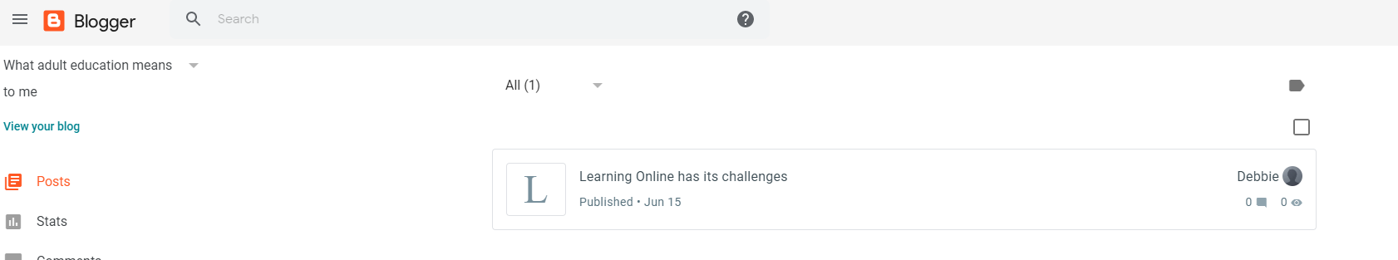
2. Other commands available on your dashboard are down the side: Posts, Stats, Comments, Earnings, Pages, Layout, Theme, Settings and Reading List where you can follow other blogs.
3. To make your blog more exciting use Themes 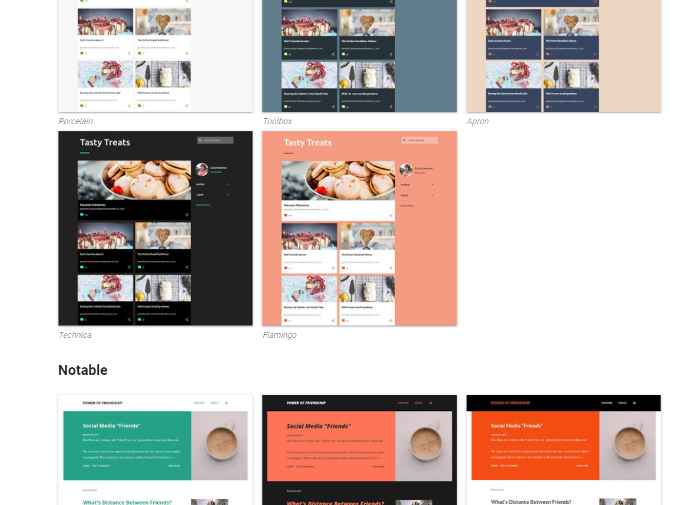
4. Under Layout you can add any of a long list of gadgets
5. 