Animoto: Directions
- Go to https://animoto.com/ Get a free account.
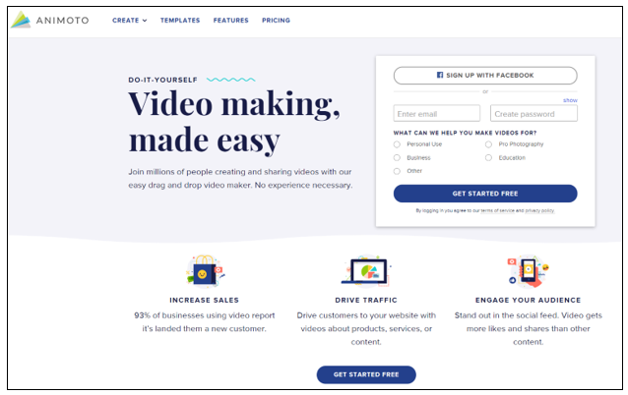
- There are a variety of templates available.
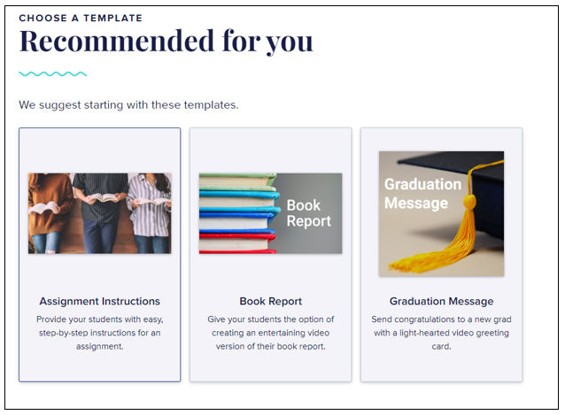

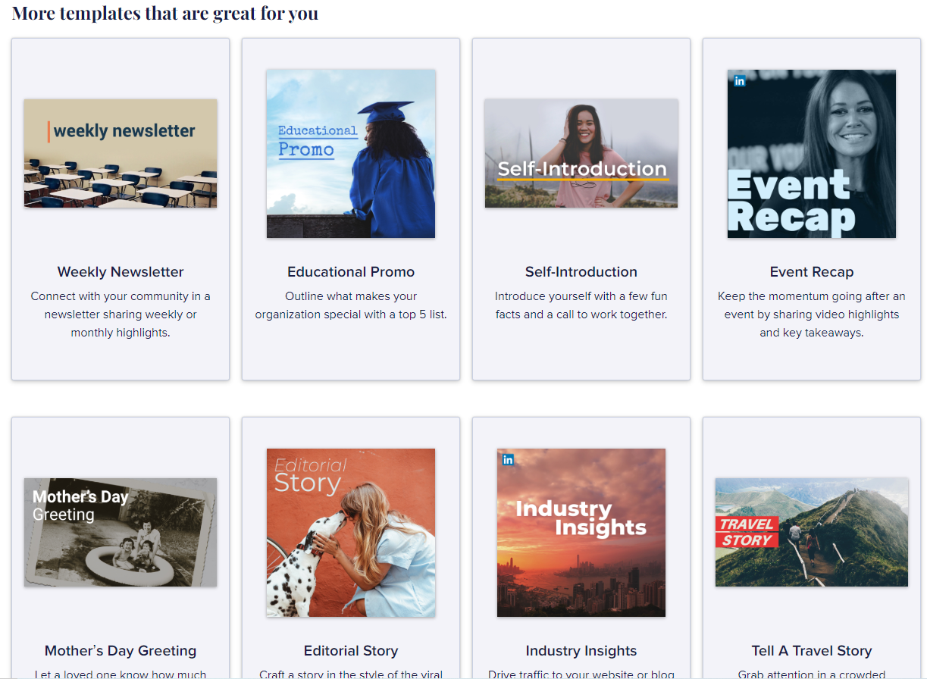
- My favorite assignments use Animoto for Vocabulary lessons or Self-Introductions. (above)
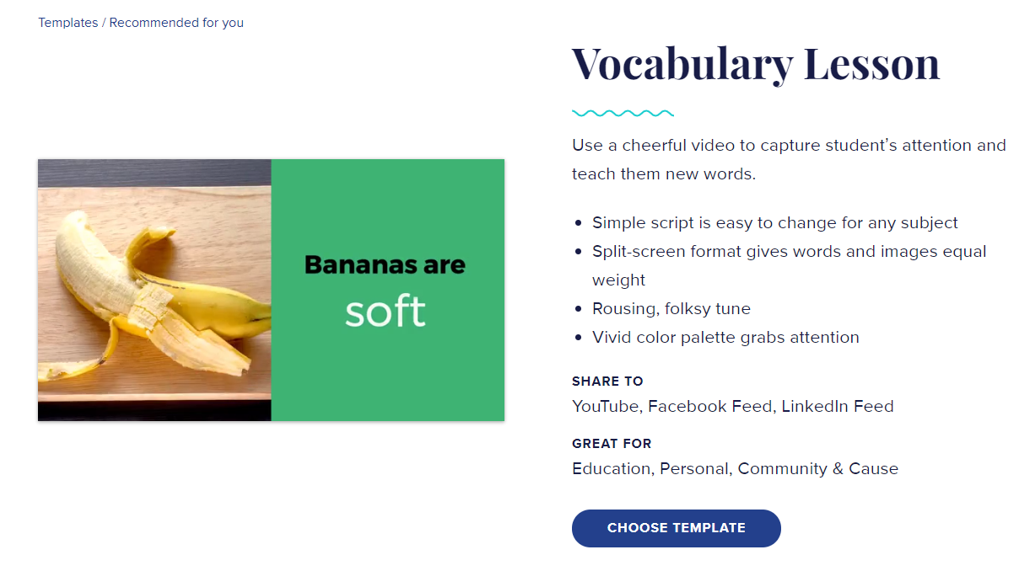
- Animoto helps you through the basic steps to build your first video.
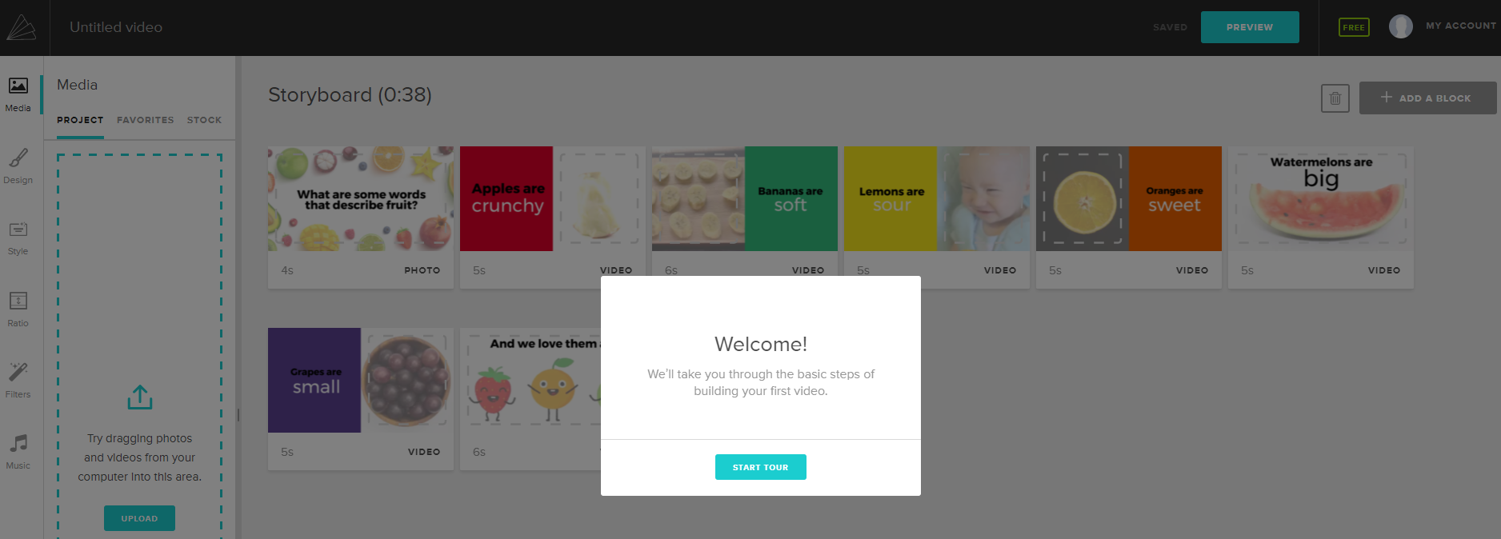
- You can add pictures and videos, drag them to change order, and add text. They allow you to select different musical styles and see and hear songs on their tune list or you can upload your own audio .mp3 file from your computer. When you are all done you can preview your video and share it on social media, by direct link, email or embed it.

