Over-the-Counter (OTC) Drug Labels

**Antihistamine label**

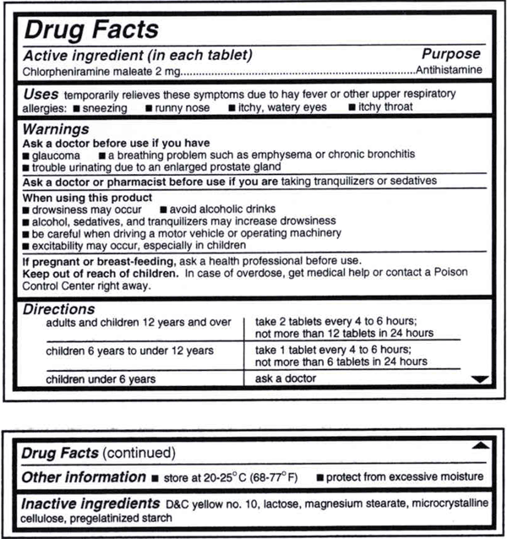

**Acid reducer**

