- Go to Canva.com. Open an account.
- Watch the Tutorial on Infographics: https://www.canva.com/learn/design/tutorials/introduction-infographics/

- You can create your graphics using Canva resources (some of their resources have a cost to use)
- Or you can upload your own graphics to Canva.
To add your own graphics to Canva: First save your graphics to your computer. You can find graphics or images at Google Images. Click on your graphic. Right click and “Save as Picture.” Put your graphics in your pictures folder on your computer. You can make a New folder to organize your graphics.
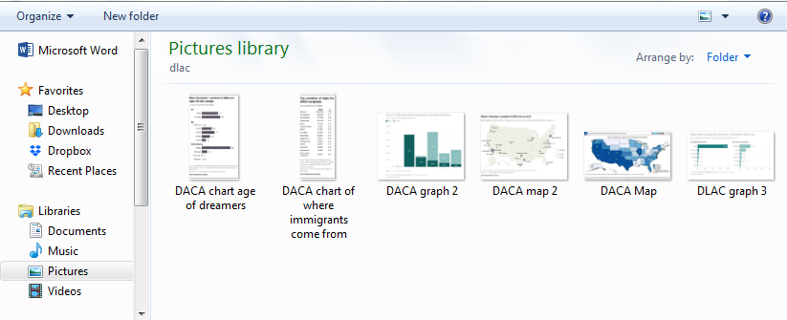

To create your infographic on Canva:
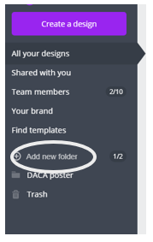
- Down the left column, select Add new folder. Name it for your project.
- Find a design you like in Find templates and drag it to your folder.
- Click on the design and on Edit.
- Upload your own images to Canva.
- Drag your images to your template
- Download your infographic.
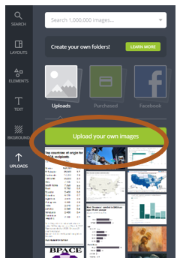 Finished Infographic:

