Example Quarter Project
This quarter you will select an interesting question you want to research. You will research the answer using at least three sources (create a bibliography). You will write what you discover. You will work in pairs to review each other’s work. To present your topic to the class, you will choose a multimedia method. This could be an animation/movie, infographic, screencast or presentation. You will evaluate your project and those of your classmates. Finally you will share your project with the class.
For this project we are going to use Trello, an online organization software. To create your Quarter Project on Trello go to trello.com
A little about Trello:
A Trello board has lists. Each list is filled with cards.
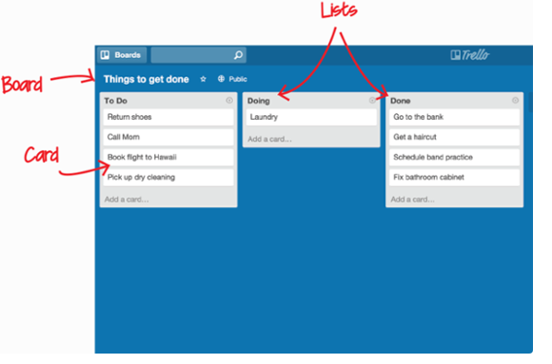

Create your board with the following headings: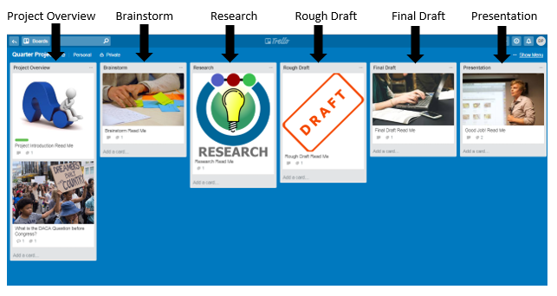
You will work through the board, one list at a time, adding your card, then moving your card as you complete each list.
For each section see the following instructions:
Quarter Project
- Project Overview: Select a question you would like to find the answer to, and share with others.
- Brainstorm: Create a list of steps you need to do to accomplish your project. Create a card and add your project title and steps to the list titled Brainstorm.
- Research your question. Find the answer. Use at least three sources. As you research your question, move your card to the Research List.
- Rough Draft: Write a first draft answer to your question. (Move your card to the First Draft List.
- Have a peer review your draft. (they will be looking for things they really like, any places they were confused, any places they wanted more information)
- Teacher input: @ mention the teacher. Have the teacher make suggestions.
- Final Draft: Consider the editing and revision suggestions. Make any corrections you think will make your writing stronger. Move your card to the Final Draft List.
- Presentation: As you prepare for your presentation to the class, include a multimedia element like a video, (i.e. Animoto), infographic (i.e. Canva), screencast (i.e. Screencastomatic) or presentation (i.e. PowerPoint or Google Slides). Add your multimedia to your card in the Final Draft list. Submit your completed Final Draft.
- Now that you have finished your project, you are ready to present your project to the class.

